Knowledge Organiser
Science | Year 4 | Term |  | Topic: Animals including humans
Prior Knowledge |  | Knowledge and application
The parts of the human body and what they do.  All animals need water, air and food to survive.  The different ways in which humans are healthy.  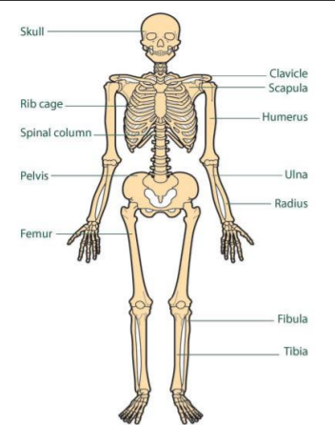  Animals get nutrition from what they eat.  Humans and some animals have skeletons and  muscles for support, protection and movement. |  | 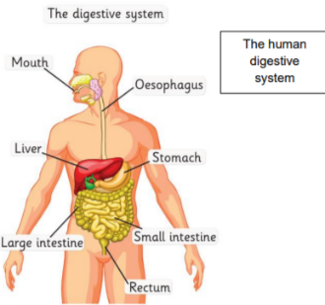  What is digestion? Digestion is the process of how the body breaks down the food we eat into smaller parts that can be used to give the body energy  The main part of the digestive system Mouth, tongue, pharynx, oesophagus, liver, stomach, gall bladder, pancreas, small intestine, large intestine.  The journey of food Humans put food into their mouth  Food is chewed by the teeth  Food is swallowed and passed through the pharynx and oesophagus to  the stomach  In the stomach, it is churned into a mixture like soup and mixed with acid  The mixture passes into the small intestine, where tiny bits of food  pass into the bloodstream  The food that is still left goes into the large intestine  Finally, waste products leave the body  Facts about teeth  Teeth grow in babies when they are about 6 months old  20 teeth grow by the time you are about 2.5 years old  From about age 6 you start to lose teeth till about the age 12  These teeth are replaced by 32 permanent teeth
What will I know by the end of this topic? |  | Key Vocabulary
Teeth  Teeth are used for cutting and chewing food.  Dental hygiene – dos and don’ts  Not looking after teeth can lead to an increase in plaque and tooth decay.  Types and features of teeth:  Canines are pointed for tearing and ripping food - these are usually used when chewing meat.  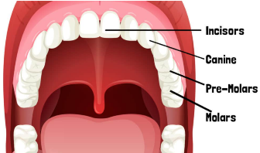  Incisors are shovel shaped and help bite lumps out of and cutting food.  Premolars and molars are flat, and they grind and crush food.  Digestive System  The features of the human digestive system: saliva, oesophagus, stomach, intestine.  The smell of food triggers saliva to be produced. The digestive system begins with the mouth and teeth where food is ingested and chewed.  The food minus the nutrients arrives in the rectum where muscles turn it into faeces. It is stored here until it is pushed out by the anus. This is called excretion. |  | Canine | pointed teeth near the front of the mouth of humans and of some animals
 |  | Decay | Decay gradually destroyed by a natural process
 |  | Digestion | Digestion breaking down ingested food material
 |  | Enamel | the hard white substance that forms the outer part of a tooth
 |  | Excretion | the process of eliminating faeces, urine, or sweat from the body
 |  | Incisor | the teeth at the front of your mouth which you use for biting into food
 |  | Intestines | the tubes in your body through which food passes when it has left your stomach
 |  | Molar | the large, flat teeth towards the back of your mouth that you use for chewing food
 |  | Plaque | a substance containing bacteria that forms the surface of your teeth
 |  | Saliva | the watery liquid that forms in your mouth and helps you to chew and digest food
 |  | Stomach | churns and makes gastric juice to help digest the food we eat and protect us from germs.
 |  | Nutrition | includes all the stuff that's in your food, such as vitamins, protein, fat, and more.
 |  | Organ | group of tissues in a living organism that has a specific form and function

