Knowledge Organiser
Science | Year 4 | Term |  | Topic: States of matter
Prior Knowledge |  | Application of Knowledge
How to describe, group and classify everyday materials  The shapes of solid objects made from some materials can be changed by squashing, bending, twisting and stretching. |  | Particles are what materials are made from. They are so small that we cannot see them with our eyes. The properties of a substance depend on what its particles are like, how they move and how they are arranged Particles behave differently in solids, liquids and gases.  In the solid state, the material holds its shape. Solids have vibrating particles which are closely packed in and form a regular pattern. This explains the fixed shape of a solid and why it can’t be poured Solids always take up the same amount of space.  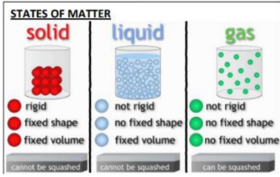  In the liquid state, the material holds the shape of the container it is in. This means that liquids can change shape, depending on the container. Liquids have particles which are close together but random. Liquid particles can move over each other. Liquids can be poured.  What is a gas?  In the gas state, particles can escape from open containers. Gases have particles which are spread out and move in all directions.
What will I know by the end of this topic? |  | Key Vocabulary
Sort materials into solids, liquids and gases  Liquids take the shape of their container  Gases can completely spread out to fill the container or room  Solids these materials keep their shape until force is applied to them  Explain the behaviour of the particles in solids, liquids and gases.  Explain how heating and cooling causes materials to melt and freeze  Water can exist in three forms: liquid (water), solid (ice) or gas (water vapour).  the melting and freezing point of water  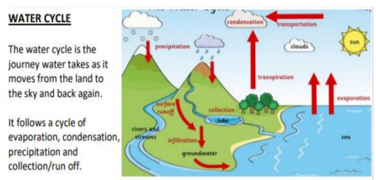  I will be able to explain the water cycle using scientific terms |  | Classify | Is to sort things into different groups
 |  | Condensation | the process of a gas cooling and changing into a liquid
 |  | Evaporation | the process of liquid heating and changing into a gas
 |  | Precipitation | release of water from the sky, it can be liquid or solid, for example, rain, sleet, hail and snow
 |  | Liquid | substance that can flow and take on the shape of a container
 |  | Gas | substance that has no fixed shape, like oxygen
 |  | Observe | The things that can be seen, watched during an experiment and taking of notes to record facts based on the experiment.
 |  | Matter | any solid, liquid or gas that exists in the universe
 |  | Melting | is when a solid changes to a liquid at the melting point by heating
 |  | Melting Point | is when the temperature at which a solid changes to a liquid
 |  | Solid | objects that keep their own shape and do not flow at a given temperature
 |  | Temperature | how hot or cold something is, normally measured in degrees Celsius (°C)
 |  | Water cycle | the process of water being recycled over and over again
 |  | Water vapour | Water vapour is water that is in the form of a vapour, or gas

