Knowledge Organiser
Science | Year 4 | Term |  | Topic: Sound
Prior Knowledge |  | Knowledge and Application
Hearing is one of my five senses.  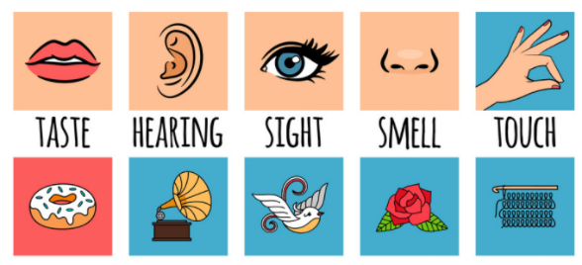  Sounds can be combine using musical instruments.    What the word vibration means. |  | Pitch:  High pitch sounds are created by short sound  waves.  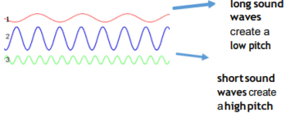  Low pitched sounds are created by long sound Waves  Volume:  The closer you are to the source of the sound, the  louder the sound will be.  The further away you are from the source of the  sound, the quieter the sound will be.  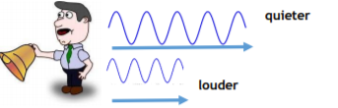
What will I know by the end of this topic? |  | Key Vocabulary
The object that makes the sound is called the source.    When objects vibrate, a sound is made. The vibration makes the air around the object vibrate and the air vibrations enter your ear. These are called sound waves.  Sound waves travel through a medium (such as air, water, glass, stone, and brick).  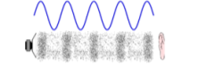  The pitch of a sound is how high or low it is.  The volume of a sound is how loud or quiet it is.  A vibration with lots of energy makes a powerful sound wave and therefore a loud sound.  Amplitude measures how strong a sound wave is.  Decibels measure how loud a sound is.  Frequency measures the number of times per second that the sound wave cycles. |  | Amplitude | a measure of the strength of a sound wave
 |  | Energy | the power from sources such as electricity that makes machines work or provides heat
 |  | Frequency | a measure of how many times per second the sound wave cycles
 |  | Medium | something that makes possible the transfer of energy from one location to another
 |  | Power | Power is energy, especially electricity, that is obtained in source and used to operate lights,
 |  | pattern seeking | making measurements or observations to explore situations where there are variables that we can't easily control
 |  | Sound waves | invisible waves that travel objects as vibrations through air, water, and solid
 |  | source | where something comes from
 |  | vibrations | invisible waves that move quickly
 |  | Volume | how loud or quiet a sound is

