Knowledge Organiser
Science | Year 4 | Term | Topic: Living things and their habitats
Prior Knowledge |  | Application of Knowledge
Describe and compare the structure of a variety of common animals (fish, amphibians, reptiles, bird and mammals, including pets)  Identify and name a variety of plants and animals in their habitats, including micro-habitats  Identify and name a variety of common wild and garden plants, including deciduous and evergreen trees  Identify and name a variety of common animals including fish, amphibians, reptiles, birds and mammals |  | Recognise that living things can be grouped in a variety of ways  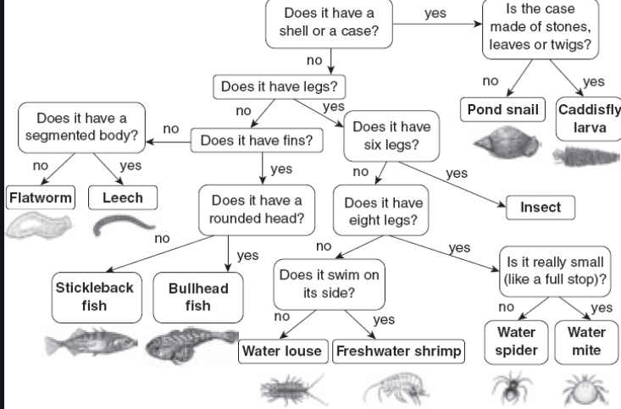  Explore and use classification keys to help group, identify and name a variety of living things in their local and wider environment  Recognise that environments can change and that this can sometimes pose dangers to living things
What will I know by the end of this topic? |  | Key Vocabulary
What does classification mean?  What is the difference between invertebrate and vertebrate?  What does migration mean?  What does hibernation mean? What is an environment?  How do humans have a negative impact on the environment?  What is an endangered animal/species?  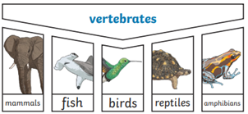  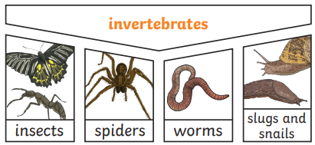 |  | organisms | This is another word that can be used to mean ‘living things’
 |  | habitat | The specific area or place in which particular animals or plants may live.
 |  | environment | There are many habitats and these include areas where there are both living and non-living things.
 |  | endangered | there are not many of their species left and the species may become extinct.
 |  | extinct | When a species has no more members alive on the planet, it is extinct.
 |  | MRS GREN  or  MRS NERG | 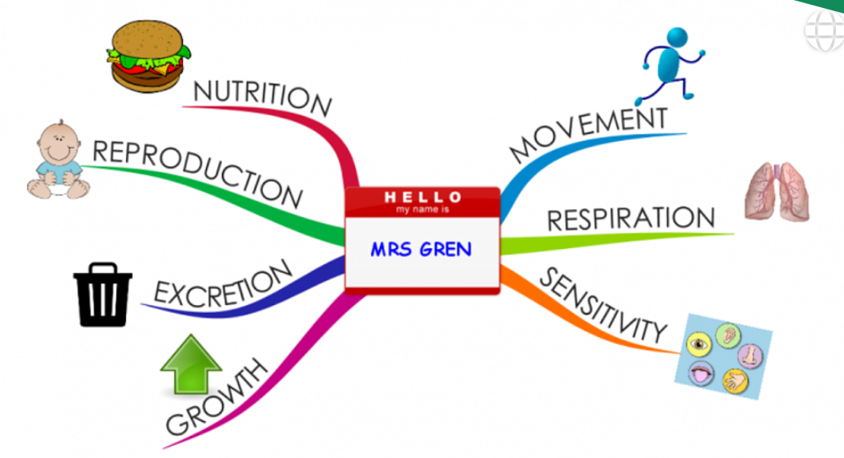
 |  | classification | Where plants or animals are placed into  groups according to their similarities
 |  | vertebrate | Animals with a backbone
 |  | invertebrate | Animals without a backbone
 |  | specimen | A particular plant or animal that scientists’ study to find out about its species.
 |  | characteristics | The distinguishing features or qualities that are specific to a species

