Knowledge Organiser
Science | Year 4 | Term |  | Topic: Electricity
Prior Knowledge |  | Application of Knowledge
Electricity is a power source  Electricity can be turned on and off  Some household objects are powered by electricity e.g. T.V |  | Identify common appliances that run on electricity  construct a simple series electrical circuit, identifying and naming its basic parts  Identify whether or not a lamp will light in a simple series circuit, based on whether or not the lamp is part of a complete loop with a battery  Recognise that a switch opens and closes a circuit and associate this with whether or not a lamp lights in a simple series circuit  Recognise some common conductors and insulators, and associate metals with being
What will I know by the end of this topic? |  | Key Vocabulary
What common appliances run on electricity?  What do you need to construct a simple electrical circuit?  What is a circuit?  What does a switch do?  What’s the difference between a conductor and insulator?  Can you name some common conductors?  Can you name some insulators?  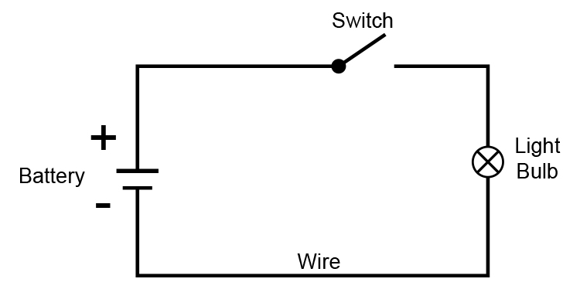 |  | Electricity | Electricity is the flow of tiny particles called electrons and protons. It can also mean the energy you get when electrons flow from place to place
 |  | Generate | To make or produce.
 |  | Renewable | A source of electricity that will not run out. These include solar, nuclear, geothermal, hydro and wind.
 |  | Non renewable | This source of energy will eventually run out and so will no longer be able to be used to make electricity. These include fossil fuels – coal, oil and natural gas
 |  | Appliance | A piece of equipment or a device designed to perform a particular job, such as an iron
 |  | Battery  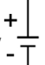 | a container consisting of one or more cells, in which chemical energy is converted into electricity and used as a source of power.
 |  | Circuit | A pathway that electricity can flow around
 |  | Cell | A cell pushes the electric current from the positive terminal round to the negative one
 |  | Wire | wires metal drawn out into the form of a thin flexible thread or rod
 |  | Switch  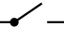 | An electrical component that can open or close a  circuit
 |  | 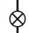  Bulb | A device for giving off light
 |  | Conductor | An object that allows electricity to travel through it.
 |  | Insulator | A material that restricts or stops electricity from travelling

