Knowledge Organiser
Science |  | Year 3 | Term | Topic: Animals including humans
Prior Knowledge |  |  | Knowledge and Application
All animals need water, air and food to survive.  The different ways in which humans can be healthy.  The parts of the human body and what they do.  There are five types of vertebrates (mammals, fish, reptiles, amphibians, birds)  Vertebrates are animals that have a backbone.  Invertebrates are animals that do not have a backbone. |  |  | Living things need food to grow and to be strong and healthy.  Plants can make their own food, but animals cannot.  To stay healthy, humans need to exercise, eat a healthy diet and be hygienic.  Animals, including humans, need food, water and air to stay alive.  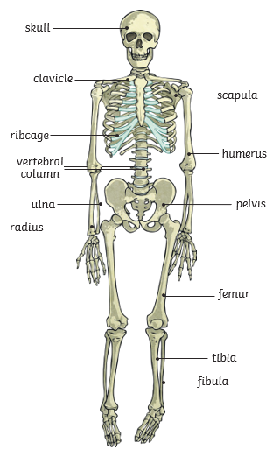  Skeletons do three important jobs:  - protect organs inside the body.  - allow movement.  - support the body and stop it from falling on the floor.  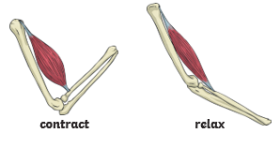  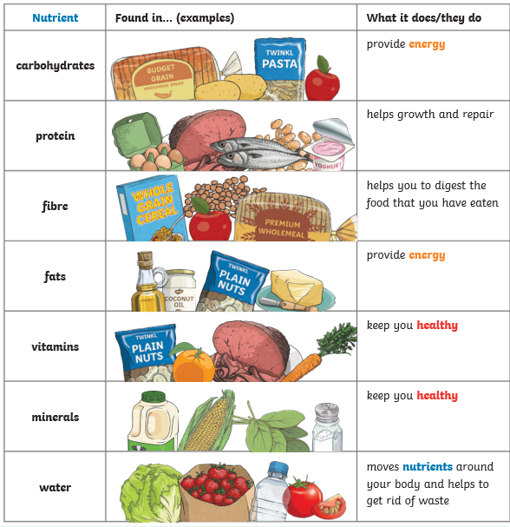  Skeletal muscles work in pairs to move the bones they are attached to by taking turns to contract (get shorter) and relax (get longer).
Humans cannot make their own food like plants do -
we need to eat plants and animals to get our energy.
Healthy, balanced diets lead to healthy, active people.

Protein foods help the body to grow and repair
- Carbohydrates give us energy
- Fats give us energy (we should eat this in
- moderation)
- Vitamins & minerals keep our bodies healthy
- Fibre helps our food digest
- Water helps to move nutrients in our body and gets rid of waste that we don’t need.

Muscles and Skeletons
The three most important things a skeleton does are:
support, help you to move and protect your organs
The are 2 types of skeleton- exoskeleton or
endoskeleton (inside) We are endoskeletons.
Joints are where bones meet - they allow our bodies to move.
Muscles contract and relax.
Muscles are connected to bones by tendons.
Key Vocabulary
nutrients | substances that help plants and animals to grow
starchy | foods that contain a lot of starch (a nutrient which gives you energy)
energy | ability and strength to do physical things
healthy | well and not suffering from any illness
backbone | the column of small, linked bones down the middle of your back (spine).
joint | the junction between two or more bones
muscle | something inside your body which connects two bones and which you use when you make a movement
protect | to prevent them from being harmed or damaged
tendons | a strong cord in a person's or animal's body which joins a muscle to a bone.

