Knowledge Organiser
Science | Year 3 | Term |  | Topic: Rocks
Prior Knowledge |  | Application of Knowledge
Soil contains nutrients and these help plants to grow.  The meaning of the word absorb.  That magma is molten rock that is formed in very hot conditions inside the earth.  Identify and compare the suitability of a variety of everyday materials for particular uses |  | There are three types of rocks that are formed naturally.  neous: When molten magma cools,igneous rocks are formed. This either cools and forms rocks under the earth’s surface, or flows  Out of erupting volcanoes as lava and may mix with other minerals. This type of rock is strong, hardwearing and non-porous.  Sedimentary:Sometimes, little pieces of rocks that have been weathered can be found at the bottom of lakes, seas and rivers.This is called sediment. Over millions of years, layers ofthis sediment builds up forming sedimentary rocks.  Metamorphic: When some igneous and sedimentary rocks are heated and squeezed (pressured), they form metamorphic rocks.  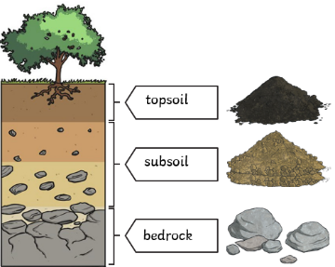  Fossils are the rem Fossils are the remains of prehistoric life.. They are usually formed when a living thing (plant or animal) dies and the body is covered up or buried by sediment over tens of thousands of years. Fossils tell us about the Earth and about life that existed hundreds of thousands and millions of years ago.  Soil is the uppermost layer of the Earth. It is a mixture of different things:  •minerals  (the minerals in soil come from finely broken-down rock);  •air;water; organic matter (including living and dead plants and animals
What will I know by the end of this topic?
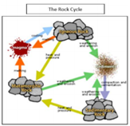
Rocks have been used by humans for millions of years, from early tools and weapons through to construction materials for modern buildings.

Sediment deposited over time, often as layers at the bottom of lakes/ oceans, forms sedimentary rocks.

Extreme pressure and heat over time forms
metamorphic rocks. Examples are marble and slate.

When magma cools and solidifies it forms igneous rock. Examples are granite and pumice.
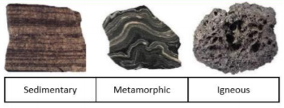
How fossils are made:
An animal dies, its skeleton settles on the sea floor and is buried by sediment.
The sediment surrounding the skeleton thickens and begins to turn to stone.

The skeleton dissolves and a mould is formed. Minerals crystallise inside the mould and a cast is formed. The fossil is exposed on the Earth's surface.

Know who Mary Anning is.

 |  | Key Vocabulary
 |  | igneous rock | Rock that has been formed from magma or lava.
 |  | sedimentary rock | Rock that has been formed by layers of sediment being pressed down hard and sticking together. You can see the layers of sediment in the rock.
 |  | metamorphic rock | Rock that started out as igneous or sedimentary rock but changed due to being exposed to extreme heat or pressure.
 |  | magma | Molten rock that remains underground.
 |  | lava | Molten rock that comes out of the ground is called lava.
 |  | sediment | Natural solid material that is moved and dropped off in a new place by water or wind, e.g. sand.
 |  | permeable | Allows liquids to pass through it.
 |  | impermeable | Does not allow liquids to pass through it.
 |  | fossilisation | The process by which fossils are made.
 |  | palaeontology | The study of fossils.
 |  | erosion | When water, wind or ice wears away land.

