Knowldge Organiser
Science | Year 3 | Term |  | Topic: Plants
Prior Knowledge |  | Knowledge and Application
Which things are living and which are not.  A variety of common wild and garden plants, and how to identify them.  The structure of common flowering plants, including trees  Seeds and bulbs grow into mature plants  Plants need water, light and a suitable temperature to grow and stay healthy.  Plants and animals depend on each other to survive. |  | 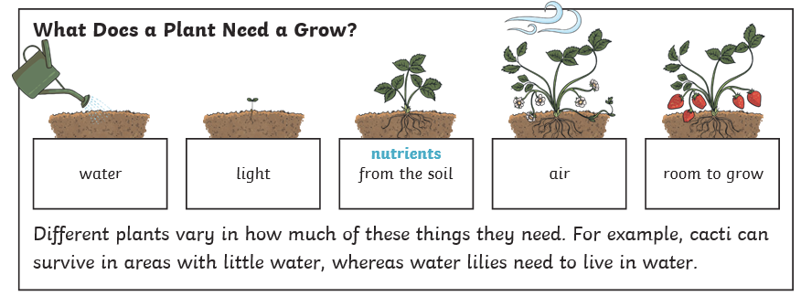  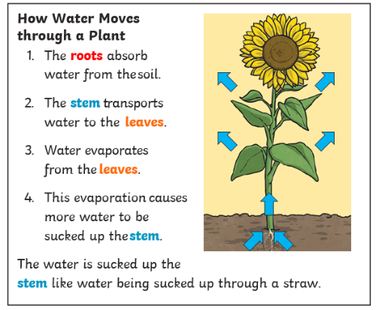  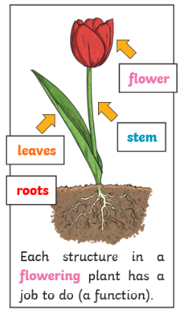
What will I know by the end of this topic?
Know the function of the different parts of the flowering plant.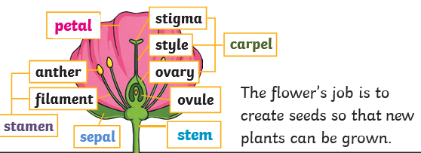
Identify and know the names of: stem; roots; leaves and flowers.

Know what a plant needs to grow.
Know that light, air, water, nutrients from soil and suitable temperature are all important for plant growth.
The amount of light, air, water, nutrients from soil and temperature may vary depending on the type of plant. For example, cacti need less water than other plants.

Find out how water is transported within a plant:
Water is absorbed from the soil by the roots and then transported from the roots to the stem and then to the rest of the plant.
Know the part that flowers play in the life cycle of a flowering plant. The flower creates the seed

Know that pollination occurs when pollen from the anther is transferred to the stigma by bees and other insects.
That the pollen travels down style and meets the ovule. When this happens, seeds are formed - this is called fertilisation. Seeds are then dispersed so that germination can begin again.
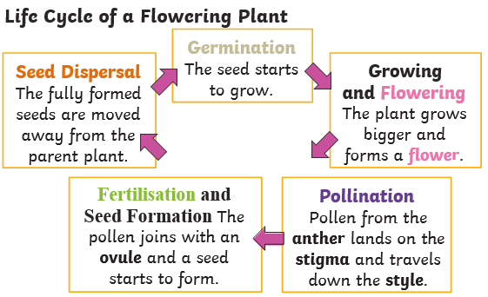

 |  | Key Vocabulary
 |  | roots | These anchor the plant into the ground and absorb water and nutrients from the soil.
 |  | stem | This holds the plant up and carries water and nutrients from the soil to the leaves. A trunk is the stem of a tree.
 |  | leaves | These make food for the plant using sunlight and carbon dioxide from the air.
 |  | flowers | These make seeds to grow into new plants. Their petals attract pollinators to the plant.
 |  | nutrients | These substances are needed by a living things to grow and survive.
 |  | evaporation | When a liquid turns into a gas.
 |  | fertilisation | When the male and female parts of the flower have mixed in order to make seeds for new plants.
 |  | petal | The brightly coloured part of the flower that attracts insects to pollinate the plant.
 |  | stamen | The male part of a flower containing pollen
 |  | carpel | The female part of a flower containing an egg
 |  | sepal | Leaf-like structures that protect the flower and petals before they open out.
 |  | pollination | To pollinate a plant or tree means to fertilise it with pollen. This is often done by insects
 |  | pollinator | Animals or insects which carry pollen between plants. Examples include birds, bees and bats.
 |  | germination | When a seed starts to grow.
 |  | seed  dispersal | A method of moving the seeds away from the parent plant so that the seeds have the best chance of survival.

