Knowledge Organiser
Science | Year 3 | Term |  | Topic: Forces and Magnets
Prior Knowledge |  | Application of Knowledge
Year 2— find out how the shapes of solid objects made from some materials can be changed by squashing, bending, twisting and stretching  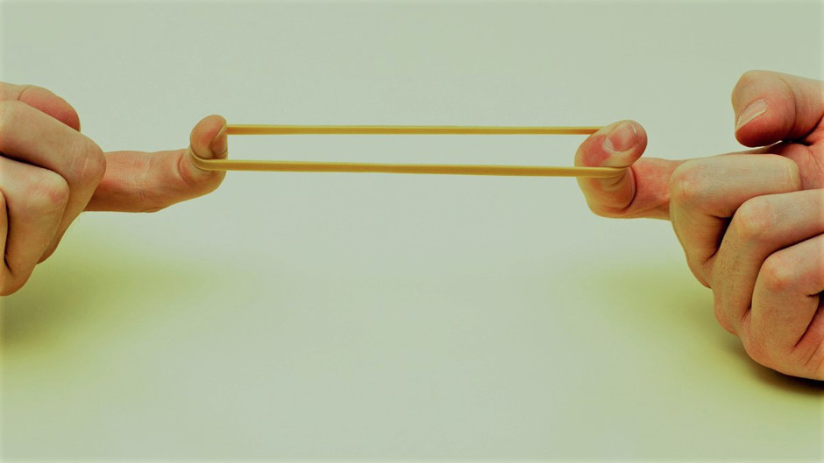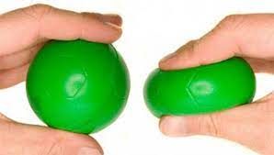  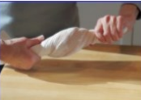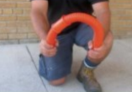 |  | notice that some forces need contact between two objects, but magnetic forces can act at a distance  observe how magnets attract or repel each other and attract Some materials and not others  compare and group together a variety of everyday materials on the basis of whether they are attracted to a magnet, and identify some magnetic materials  describe magnets as having two poles  predict whether two magnets will attract or repel each other, depending on which poles are facing
What will I know by the end of this topic? |  | Key Vocabulary
What objects are attracted to magnets?  What objects are repelled by magnets?  Can you describe the features of a magnet?  Which way do magnets have to face each other to attract each other?  Which way do magnets have to face each other to repel each other?  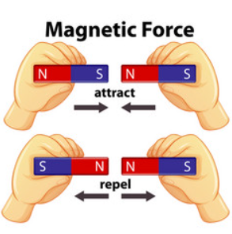 |  | Force | Pushes or pulls
 |  | Friction | A force that acts between two surfaces or objects that are moving, or trying to move, across each other.
 |  | surface | The top layer of something.
 |  | magnet | An object which produces a magnetic force that pulls certain objects towards it.
 |  | magnetic | Objects which are attracted to a magnet are magnetic. Objects containing iron, nickel or cobalt metals are magnetic.
 |  | magnetic field | The area around a magnet where there is a magnetic force which will pull magnetic objects towards the magnet.
 |  | poles | North and south poles are found at different ends of a magnet.
 |  | repel | Repulsion is a force that pushes objects away. For example, when a north pole is placed near the north pole of another magnet, the two poles repel (push away from each other).
 |  | attract | Attraction is a force that pulls objects together. For example, when a north pole is placed near the south pole of another magnet, the two poles attract (pull together).

