Knowledge Organiser
Science | Year 3 | Term |  | Topic: Light
Prior Knowledge |  | Knowledge and Application
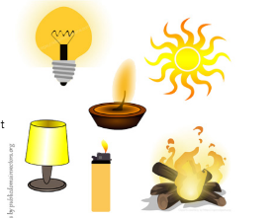  Certain things produce light, usually by burning  (e.g. the Sun) or electricity (e.g. street lights)  Shadows are caused when certain materials block light.  I know I can use my eyes to see things (senses). |  | 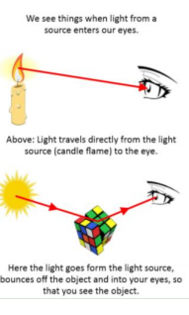  We need light to be able to see things. Light travels in a straight line. When light hits an object, it is reflected (bounces off). If the reflected light hits our eyes, we can see the object. Some surfaces and materials reflect light well. Other materials do not reflect light well. Reflective surfaces and materials can be very useful.  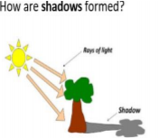  Mirrors reflect light very well, so they create a clear image. An image in a mirror appears to be reversed. For example, if you look in a mirror and raise your right hand, the mirror image appears to raise its left hand.  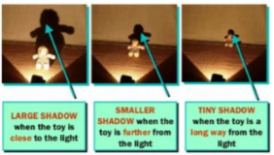  Shadows are formed when an object (tree) blocks light travelling from a light source (the sun). The shadow is always on the opposite side of the object to the light source.  The size of a shadow changes as the  light source moves. The further away  the light source is, the smaller the  shadow is. The closer the source of  the light, the bigger the shadow.
What will I know by the end of this topic?
Light travels in straight lines from a light source. We see objects because light reflects off of them and into our eyes.

We need light in order to see things and that dark is the absence of light.

We must never look directly at the Sun as the light produced is very bright and can be harmful to our eyes. This is why we wear sunglasses.

Electric lights include lamps, car headlights and streetlight.

Some surfaces can reflect light. Shiny things are not light sources - they appear to be sources of light as they are bright.

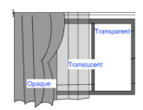
If something gets in the way of light, a shadow is formed. An opaque object, blocks light so a dark shadow is formed. A translucent object lets through some light, and still has a shadow. A transparent object lets through all light and a faint shadow maybe seen.

The size of a shadow changes as the light source moves and this changes during the day and seasons.
 |  | Key Vocabulary
 |  | bright | A colour that is strong and noticeable dark the absence of light dim light that is not bright
 |  | electric | A form of energy that provides power to devices. light a brightness that lets you see things
 |  | mirror | a flat piece of glass which reflects light, and other objects
 |  | opaque | an object you cannot see through it
 |  | product | something that is produced
 |  | reflects | sent back from the surface and not pass through it
 |  | translucent | if a material is translucent, some light can pass through it
 |  | transparent | if a material is translucent, some light can pass through it
 |  | shadow | A dark shape on a surface that is made when something stands between a light and the surface
 |  | source | where something comes from surface the flat top part of something or the outside of it
 |  | torch | a small electric light which is powered by batteries and which you can carry
 |  | warning | Something that is said or written to tell people of danger.

