Knowledge Organiser
Science |  | Year 1 | Term |  | Topic: Plants
Prior Knowledge |  |  | Application of Knowledge
Begins to plant seeds and care for growing plants.  Begin to understand the need to respect and care for the natural environment  Begins to understand the key features of the life cycle of a plant.  Explores the natural world around them,  making observations and drawing  pictures of plants |  |  | Identify and name a variety of common wild and garden plants, including deciduous and evergreen trees  Identify and describe the basic structure of a variety of common flowering plants, including trees.  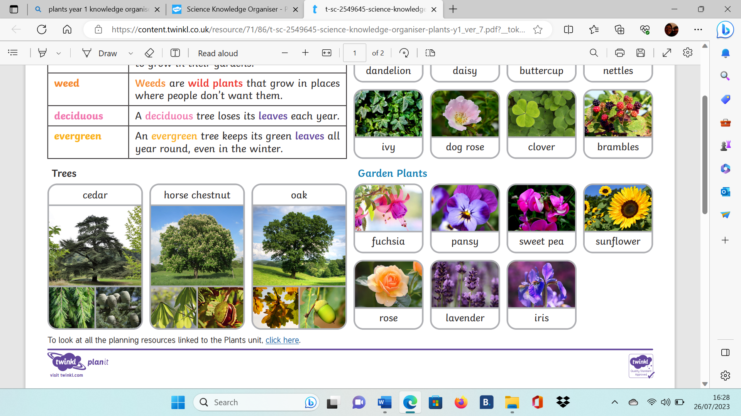
What will I know by the end of this topic?
Name the parts of a flowering plant.
Identify and name common wild and garden plants, including deciduous and evergreen
trees.
Name 3 things that plants need to grow and stay healthy.
Know the difference between thing that are living, dead and that never been alive and
name one of each.
To know that plants live in habitats to which they are suited.
Key Vocabulary
Wild plant | A wild plant seed grows where it falls. It doesn’t need to be planted or cared for as it grows. |  |  | 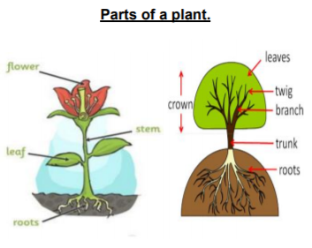  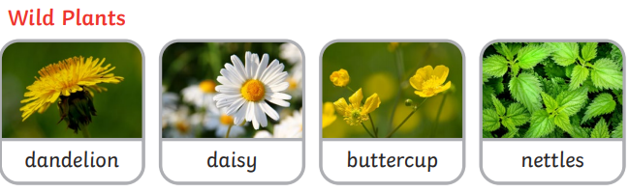  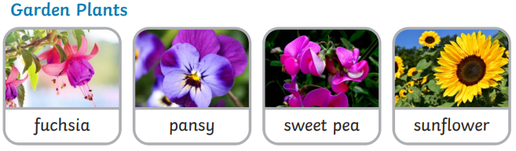
Garden plant | Garden plants are plants that people choose to grow in their gardens.
weeds | Weeds are wild plants that grow in places where people don’t want them.
deciduous | A deciduous tree loses its leaves each year.
evergreen | An evergreen tree keeps its green leaves all year round, even in the winter
roots | Roots take in water and nutrients from the soil and keep the plant in the ground.
leaves | Leaves catch sunlight to help the plant to make its own food.
flowers | Flowers attract insects and birds.
petals | Petals are the colourful part of the flower
fruit | Fruit contains the plant’s seeds.
seeds | Seeds grow into new plants
bulbs | Bulbs grow into new plants

