Knowledge Organiser
Science |  | Year 1 | Term |  | Topic: Everyday Materials
Prior Knowledge |  |  | Application of Knowledge
Talk about the differences between materials and changes they notice  Recognise objects can be made from the same or different materials  Begin to recognise why certain materials are used for certain objects  Describe what they see, hear and feel whilst outside |  |  | Distinguish between an object and the material from which it is made  Identify and name a variety of everyday materials, including wood, plastic, glass, metal, water, and rock  Describe the simple physical properties of a variety of everyday materials  Compare and group together a variety of everyday materials on the basis of their simple physical properties
What will I know by the end of this topic?
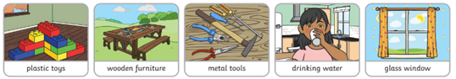
I will know the properties of everyday objects
I can use specific vocabulary to describe a variety of materials
I can compare and group materials based on their properties
Certain materials are used for different reasons
An object can be made out of different materials used together
Key Vocabulary
material | Materials are what an object is made from. |  |  | 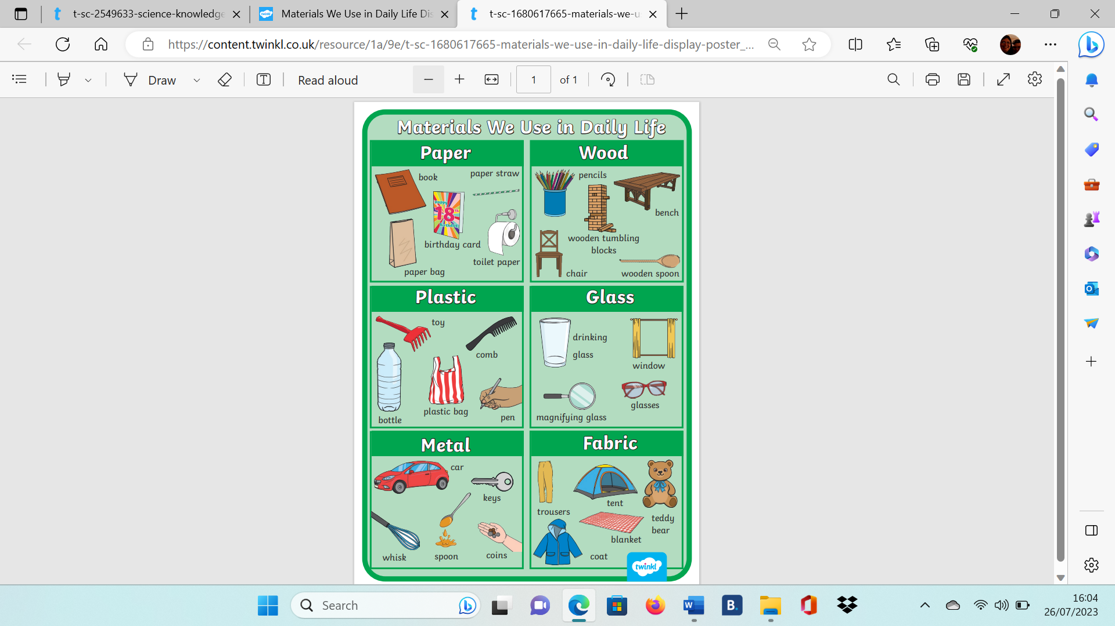
hard | Not easily broken or bent.
soft | If something is soft, it is easy to cut, fold or change the shape of.
stretchy | Can be pulled to make it longer or wider without breaking.
shiny | Reflects light easily.
dull | Doesn’t reflect light. Doesn’t look bright or shiny.
rough | If something is rough, it feels and looks uneven or bumpy.
smooth | Smooth objects have no lumps or bumps.
bendy | Bendy things can be bent easily into a curved or folded shape.
not bendy | If something is not bendy, it can’t be bent easily into a curved or folded shape.
waterproof | If something is waterproof, it keeps water out. It keeps things dry.
not waterproof | Not waterproof materials let water in.
absorbent | If something is absorbent, it soaks water up.
not absorbent | not absorbent, it does not soak up water.
transparent | Transparent objects can be seen through.
opaque | Opaque objects can’t be seen through

