Knowledge Organiser
Science | Year 2 | Term | Topic: Animals including Humans
Prior Knowledge |  | Knowledge and Application
I know that humans have 5 senses: smell, hear, taste, touch and sight. I know which body part is used with each sense.  I can name my body parts and label them in a picture  Ican identify and name common fish, amphibians, reptiles, birds and mammals  I know what a carnivore, herbivore and omnivore eats.  I can describe and compare different common animals |  | I can notice that animals, including humans, have offspring which grow into adults  I can find out about and describe the basic needs of animals, including humans, for survival (water, food and air)  I can describe the importance for humans of exercise, eating the right amounts of different  types of food, and hygiene.
What will I know by the end of this topic? |  | Key Vocabulary
I recognise the stages of a life cycle for animals and humans  I understand the sequence of life cycles  I know specific life cycle vocabulary  I can identify the basic needs for survival for animals and humans  I understand the importance of nutrients and exercise for humans  I recognise how a human can stay healthy  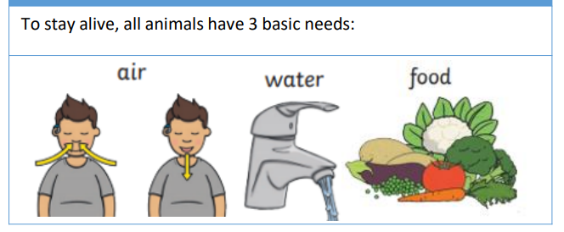  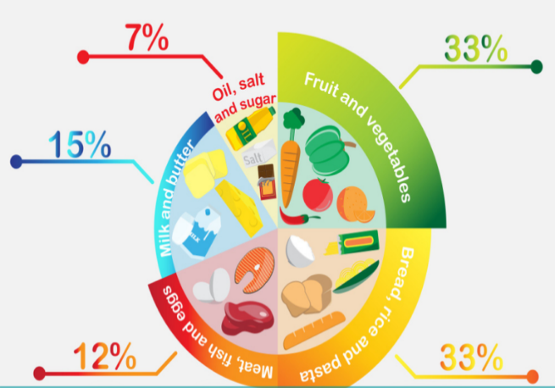 |  | 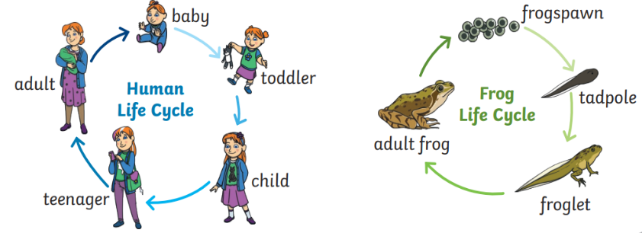
  Life cycle | The changes living things go through to become an adult
  Adult | A fully grown animal or plant.
  Offspring | The child of an animal.
  Young | Offspring that has not reached adulthood
  Live young | Offspring that has not hatched from an egg.
  Reproduce | When living things make a new living thing of the same kind
  Develop | To grow bigger and become stronger
  Diet | The food and water that an animal needs.
  Exercise | A physical activity to keep your body fit.
  Hygiene | How we keep ourselves and the world around us clean so we can stay healthy and stop germs spreading
  Nutrition | Food needed to live.
  Germs | Tiny living things that can cause disease
  Disease | Illness or sickness which affects people, animals or plants
  Medicine | A drug or other substance used to treat disease, injury, pain or other symptoms

