Knowledge Organiser
Science | Year 2 | Term |  | Topic: Plants
Prior Knowledge |  | Knowledge and Application
Plants can grow.  I can name of some common garden and common wild plants  Deciduous trees lose their leaves in the autumn every year.  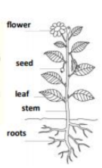  Evergreen trees have green leaves all year round.  The parts of a plant including petals, fruits, roots, bulbs, seeds, stem, trunks and branches. |  | Identify and describe the basic structure of a variety of common flowering plants, including trees.  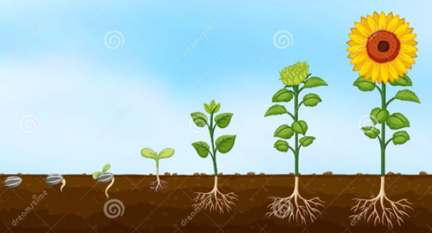  Observe and describe how seeds and bulbs grow into mature plants  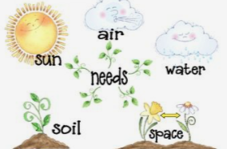  Find out and describe how plants need water, light and a suitable temperature to grow and stay healthy.
What will I know by the end of this topic?
Plants need things such as water, warmth, nutrients from soil and light to grow.
If they do not have one or more of these things, they may stop growing.
Plants can: move, grow, react to their surroundings (sense), absorb nutrients and reproduce

Which plants do we eat?
Many plants provide us with food by bearing fruits which carry their seeds.
When farmers grow plants to provide us with food, these are called crops.

We eat many fruits that contain seeds (including tomatoes!).
We also eat different parts of vegetable plants: root vegetables (carrots, potatoes), stem vegetables (celery, spring onion), leafy vegetables (cabbage, lettuce), flowering vegetables (cauliflower, broccoli)
Grains and cereals are from plants too (wheat, oats).
Nuts and seeds are also sometimes edible (sesame seeds, pumpkin seeds, peanuts).
Many herbs are also grown to add flavour to foods.
 |  | Key Vocabulary
 |  | germination | When the conditions are right, the seed soaks up water and swells, and the tiny new plant bursts out of its shell.
 |  | sprout | When a plant sprouts, it grows new shoots.
 |  | shoot | A shoot grows upwards from the seed or plant to find sunlight.
 |  | seed dispersal | Seed dispersal is when the seeds move away from the parent plant. They can be moved by the wind or animals.
 |  | sunlight | All plants need light from the sun to grow well. Some plants need lots of sunlight. Some plants only need a little sunlight.
 |  | water | All plants need water to grow. Without water, seeds and bulbs will not germinate.
 |  | temperature | how warm or cold something or somewhere is.
 |  | nutrition | Food or nourishment. Plants make their own food in their leaves using sunlight.

