Knowledge Organiser
Science | Year 2 | Term |  | Topic: Living things and their habitats
Prior Knowledge |  | Knowledge and Application
Which things are living, dead and things which have never been alive.  The names of some common plants and types of trees.  Some animals are suitable to be kept as pets but others are not.  All animals need water, air and food to survive  Animals can be grouped into vertebrates and invertebrates  Animals can be grouped into carnivores, herbivores and omnivores  Animals, including humans, have offspring which grow into adults. |  | 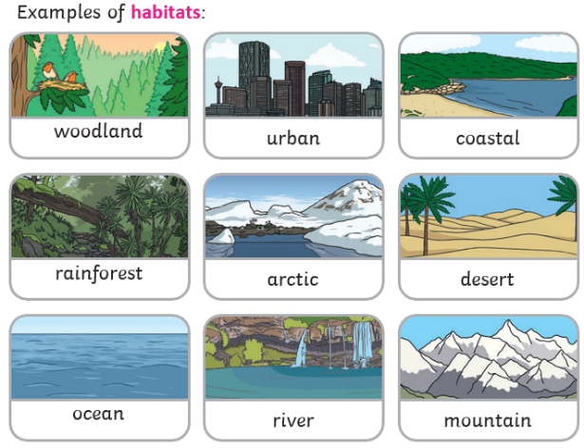  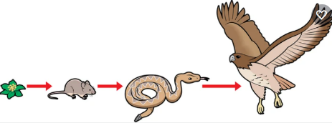  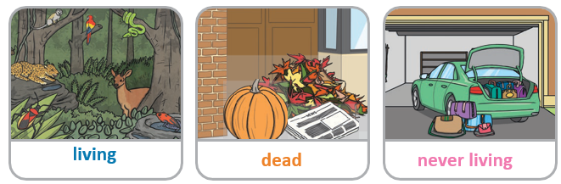
What will I know by the end of this topic?
Living things are plants (including seeds) and animals.
Dead things include dead animals and plants and parts of plants and animals that are no longer attached e.g. leaves and twigs, shells, fur, hair and feathers.
An object made of wood is classed as dead.
Objects made of rock, metal and plastic have never been alive.

Habitats
A habitat is a place where living things, such as animals and plants, can find all of the things they need to survive. This includes food, water, air, space to move and grow and some shelter.
Micro-habitat
Minibeasts that can be found there include worms, snails, ants, centipedes, millipedes, and butterflies and they help to keep the microhabitat healthy.
Minibeasts are able to survive in their habitats because they can find the things they need to survive there, such as food
and water.

Food Chains
Animals and plants depend on each other to survive. They give each other energy to survive.
If there were no worms, there would be less birds as there would be more competition for food. The soil would not be as healthy without worms
 |  | Key Vocabulary
 |  | Life processes | These are the things that all living things do. They move, breathe, sense, grow, make babies, get rid of waste and get their energy from food.
 |  | Living | Things that are living have all the life processes
 |  | dead | Things that are dead were once living. They did have all the life processes but don’t now.
 |  | Never living | Things made out of metal, plastic or rock were never living. They never had the life processes.
 |  | Food chain | A food chain shows how each animal gets its food. Food chains are one of the ways that living things depend on each other to stay alive.
 |  | Food source | This is the place living thing’s food comes from.
 |  | habitat | A habitat is the natural place something lives. A habitat provides living things with everything they need to survive such as food, shelter and water.
 |  | microhabitat | A microhabitat is a very small habitat in places like under a rock, under leaves or on a branch. Minibeasts live in microhabitats. The microhabitats have everything they need to survive.
 |  | survive | to stay alive

