Knowledge Organiser
Science | Year 2 | Term |  | Topic: Materials
Prior Knowledge |  | Knowledge and Application
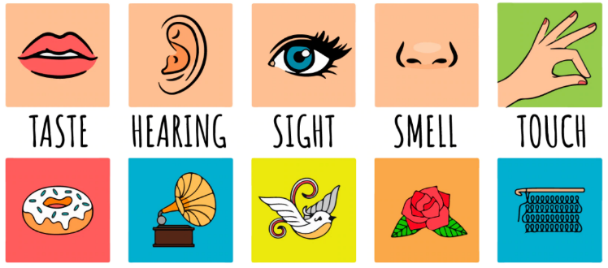  Objects are things that you can touch or see.  Objects are made from materials.  Some materials that objects are made from (e.g. glass, wood, plastic)  Some words to describe materials (e.g. shiny, soft, rough absorbent)  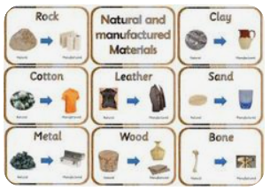  Materials which are natural and which are man-made |  | 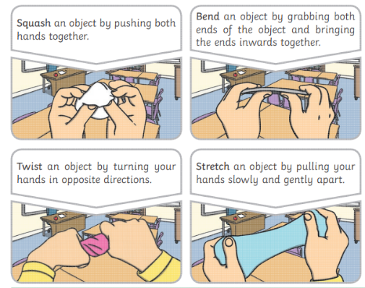  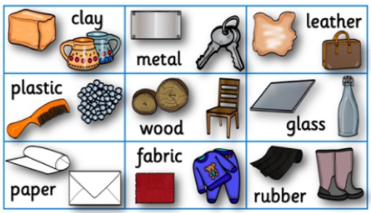
What will I know by the end of this topic? |  | Key Vocabulary
What materials are used for:  Materials are used for different purposes based on their properties  Wood is used to make furniture and floors.  Metal can be used to make coins, cans, cars and cutlery.  Glass can used to make windows.  Properties for different materials how why they are used:  Glass can used to make windows because it is  transparent.  Rulers can be made from wood, plastic or rubber because these materials are smooth and can be cut straight.  Spoons are made from metal because it is waterproof and can be cleaned easily.  They can also be made from plastic for children because plastic is light, and it cannot hurt children’s growing teeth.  I know how the shape of some materials can be changed when they are stretched, twisted, bent and squashed. |  | Absorbent | A material that quickly soaks up liquid
 |  | Bendy | A material that moves easily into a curved shape
 |  | Dull | A colour or light that is not bright.
 |  | Man made | Materials created by people
 |  | Natural Materials | that are made by nature.
 |  | Opaque | A material that you cannot see through.
 |  | Properties | Features or qualities of a material.
 |  | Purpose | The reason for which something is made or done.
 |  | Recyclable | Materials which can be reused again and again.
 |  | Rough | Uneven and not smooth
 |  | Shiny | Bright and does not reflect light.
 |  | Smooth. | No roughness, hole or bumps
 |  | Soft | Not rough or hard.
 |  | Squash | Pressed or crushed so that it loses its shape.
 |  | Stiff | Does not bend easily.
 |  | Transparent | A material that you can see through.
 |  | Waterproof | Does not let water pass through it.

