Hinguar Primary School and Nursery - SECAT
Knowledge Organiser
French | Year Five | Summer Term |  | Topic: All about me
Prior Knowledge |  | Application of Knowledge
- Identify classroom items.  - Able to ask and respond to simple welcome questions.  - Copy and write a simple word.  - Family and friends  Key Hinge Questions  - Qu’est-ce qu’il mange? |  | Listen and Speaking and Oracy  - repeat modelled words.  - say a simple phrase that may contain an adjective to describe people, places, things and actions using a language scaffold.  Reading and Writing  - read and show understanding of simple phrases and sentences containing familiar words.  - copy a simple phrase that may contain an adjective to describe things and actions using a language scaffold;
What will I know by the end of this topic? |  |  | Key Vocabulary
All  - say and match words and phrases linked to clothes, actions, and body.  - identify some colours.  - copy and write simple words.  Some  - read and write key words and phrases linked to clothes, actions, and body.  - identify some colours.  - copy and write simple words.  - order sentences correctly  copy and write a simple sentence |  | Animals
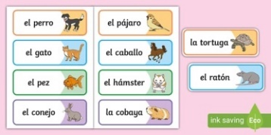
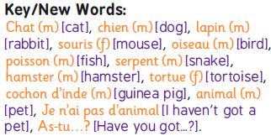
 |  | Body Parts and Actions
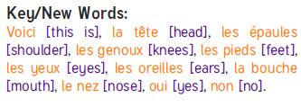
(the) head — (la) cabeza, (the) hair — (el) pelo.
(the) neck — (el) cuello, (the) chest — (el) pecho.
(the) arm — (el) brazo. (the) finger — (el) dedo.
(the) foot — (el) pie, (the) face — (la) cara.

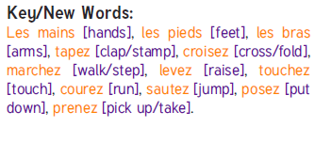
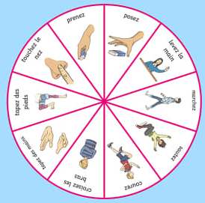

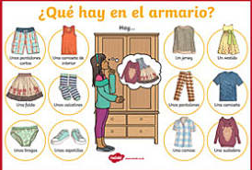

 |  | Clothes
 |  | 

