Hinguar Primary School and Nursery - SECAT
Knowledge Organiser
French / Spanish | Year Six | Summer Term | Topic: Holidays and Hobbies
Prior Knowledge |  | Application of Knowledge
- Count in 1’s, 10 and 100  - Write a couple of sentences using the topic vocabulary.  - Be able to have a simple conversation about myself, family and school.  Key Hinge Questions  Quel est ton sport préféré? Que deporte te gusta jugar. Qu’est-ce-que c’est? Tu aimes …? |  | Listen and Speaking and Oracy  - ask and answer at least two simple and familiar questions with a response.  - present ideas and information in simple sentences using familiar and rehearsed language to a partner or a small group of people.  - say one or two short sentences that may contain an adjective to describe people, places, things and actions.  Reading and Writing  - read and show understanding of simple phrases and sentences containing familiar words.  - write familiar short phrases from memory with understandable accuracy;  - use strategies for memorisation of vocabulary;  - write one or two simple sentences that may contain an adjective to describe people, places, things and actions.
What will I know by the end of this topic?
All
- Listen and respond to topic vocabulary.
- Answer questions orally using the topic vocabulary.
- Write a short paragraph using the topic vocabulary, with support.
- Present ideas and information orally to a range of audiences
Some
- Compare Spanish and French words and link back to English.
- Try a new language and discuss comparisons.
Key Vocabulary Sports
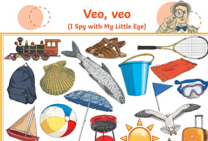  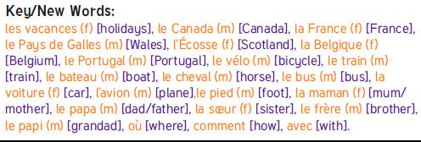  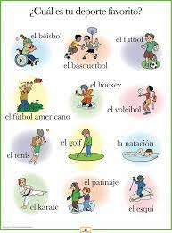  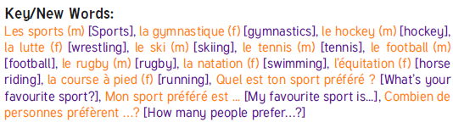 |  | La gymnastique |  | gymnastics
 |  | Le hockey |  | hockey
 |  | Le ski |  | Ski-ing
 |  | Le tennis |  | tennis
 |  | Le football |  | football
 |  | La nation |  | swimming
 |  | L’équitation |  | horse riding
 |  | Mon sport préféré est … |  | My favourite sport is ...
 |  | Hobbies
 |  | Le skateboard |  | skateboarding
 |  | La lecture |  | reading
 |  | L’informatique |  | computers/IT
 |  | La danse |  | dance
 |  | J’aime / J’adore |  | I like/ I love

