KS2 French Progression Map (Skills progression and lesson)
Please find the skills progression and lessons to follow for MFL from Years 3-6. MFL is currently scheduled to take place every other week. If you find you have extra time in a week then please recap the vocabulary taught so far. You can also try to recap and remember vocabulary for example, by answering the register with a word they’ve learnt that week or the previous week or when they line up say a word in Spanish / French or count in French etc.. As always any issues or worries, please ask.

Listen and Speaking and Oracy  repeat modelled words;  listen and show understanding of single words through physical response;  repeat modelled short phrases;  listen and show understanding of short phrases through physical response.  recognise a familiar question and respond with a simple rehearsed response;  ask and answer a simple and familiar question with a response;  use familiar vocabulary to say a short sentence using a language scaffold;  identify individual sounds in words and pronounce accurately when modelled;  start to recognise the sound of some letter strings in familiar words and pronounce when modelled;  adapt intonation to ask questions or give instructions;  show awareness of accents, elisions and silent letters; begin to pronounce words accordingly.  name nouns and present a simple rehearsed statement to a partner;  present simple rehearsed statements about themselves, objects and people to a partner;  present ideas and information in simple sentences using familiar and rehearsed language to a partner or a small group of people.  say one or two short sentences that may contain an adjective to describe people, places, things and actions | Reading and Writing  read and show understanding of familiar single words;  read and show understanding of simple phrases and sentences containing familiar words.  use strategies for memorisation of vocabulary;  use context to predict the meaning of new words;  identify individual sounds in words and pronounce accurately when modelled;  begin to pronounce words accordingly.  write single familiar words from memory with understandable accuracy;  write familiar short phrases from memory with understandable accuracy;  copy simple familiar words to describe people, places, things and actions using a model;
Year 3 Autumn – Spanish - Getting to Know You

Lesson 1 Hello | Lesson 2 What’s your name? | Lesson 3 How are you? | Lesson 4 Goodbye | Lesson 5 Numbers 0-10 | Lesson 6 How old are you?
I can say hello for different times of day.  Buenas! – Short way to say Good morning/afternoon etc.  Encantado/a or Mucho Gusto – Nice or pleased to meet you.  Adiós / Hasta luego – Goodbye / Bye. | I can introduce myself to someone else.  I can ask another person their name.  To introduce yourself, simply say "Me llamo" (may YAHM-oh) followed by your name. For example, "Hola, me llamo Chris" ("OH-la, may YAHM-oh Chris") means "Hi, I'm Chris." | .I can choose the appropriate phrase to say how they feel.  If you'd like to say “Hi, how are you?” in Spanish, you can use “Hola, ¿cómo estás?” | I can say goodbye in a variety of ways.  I can use formal and informal language.  Adiós / Hasta luego – Goodbye / Bye.  Hasta pronto – See you soon. | To say the numbers 0-10 in Spanish.  uno (ooh-no), dos (dohs), tres (trays), cuatro (kwah-troh), cinco (seen-koh), seis (says), siete (syay-tay), ocho (oh-choh), nueve (nway-vay), diez (dyays). | I can ask how old someone is.  I can say my own age.  I can use number words in my sentences.  verb tener  In Spanish, we use the verb tener (to have) to talk about age. To say I am [number] years old, we use tengo + [number of years] + años. Yo tengo veintiséis años. I am twenty-six years old.

Year 3 Spring – French – Getting to Know You

Lesson 1 Hello | Lesson 2 What’s your name? | Lesson 3 How are you? | Lesson 4 Goodbye | Lesson 5 Numbers 0-10 | Lesson 6 How old are you?
I can say hello for different times of day.  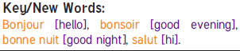 | I can introduce myself to someone else.  I can ask another person their name.  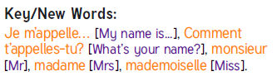 | I can use Comment ca va? As a question.  I can choose the appropriate phrase to say how they feel.  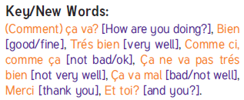 | I can say goodbye in a variety of ways.  I can use formal and informal language.  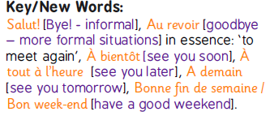 | To say the numbers 0-10 in French.  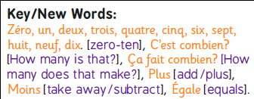 | I can ask how old someone is.  I can say my own age.  I can use number words in my sentences.  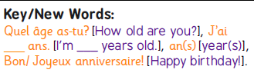

Year 3 Summer – Family and Friends
Lesson 1  Meet My Family | Lesson 2  Pets | Lesson 3  Alphabet | Lesson 4  What’s your name? | Lesson 5  How do you spell? | Lesson 6  My Home
I can identify family.  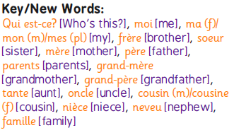  Spanish  padre: father, madre: mother  hermano: brother, hermana: sister | I can use gestures to help me remember the vocabulary.  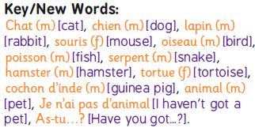  Spanish  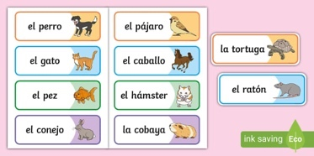 | I can copy what I hear.  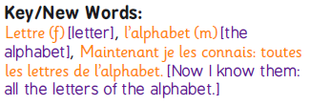  Spanish  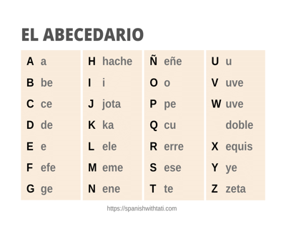 | I can use il and elle for he and she.  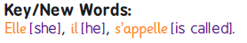  Spanish  They are called kittens, and I know do.  Se llaman gatitos, y ya sé que lo disfrutas.  They are called  Se llaman  They are called  En algunas unidades se les llama | I can say letters of the Spanish / French alphabet.  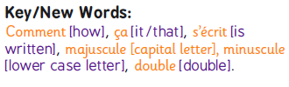  Spanish - There are several ways of saying “you” (second person). ...  Nouns are assigned genders and reflect number. ...  The verb form reflects the subject of the sentence. ...  Subject pronouns are optional. ...  Not all phrases translate word for word. | I can swap key words to make new sentences.  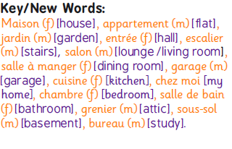  Bedroom – la habitación / el cuarto / el dormitorio  Living room – el salón / la sala de estar  Dining room – el comedor  Kitchen – la cocina  Bathroom – el cuarto de baño  Hallway – el pasillo

Year 4 Autumn – Spanish Focus - Getting to Know You (revisit from Year 3 autumn term)

Lesson 1 Hello | Lesson 2 What’s your name? | Lesson 3 How are you? | Lesson 4 Goodbye | Lesson 5 Numbers 0-15 | Lesson 6 How old are you?
I can say hello for different times of day.  Buenas! – Short way to say Good morning/afternoon etc.  Encantado/a or Mucho Gusto – Nice or pleased to meet you.  Adiós / Hasta luego – Goodbye / Bye.  Hasta pronto – See you soon.  Nos vemos – See you.  Cuídate! – Take care | I can introduce myself to someone else.  I can ask another person their name.  To introduce yourself, simply say "Me llamo" (may YAHM-oh) followed by your name. For example, "Hola, me llamo Chris" ("OH-la, may YAHM-oh Chris") means "Hi, I'm Chris." | .I can choose the appropriate phrase to say how they feel.  If you'd like to say “Hi, how are you?” in Spanish, you can use “Hola, ¿cómo estás?” (informal/singular). If you are greeting someone in a more formal setting, you'll want to use “Hola, ¿cómo está?” (formal/singular). | I can say goodbye in a variety of ways.  I can use formal and informal language.  Adiós / Hasta luego – Goodbye / Bye.  Hasta pronto – See you soon.  Nos vemos – See you.  Cuídate! – Take care | To say the numbers 0-15 in Spanish.  uno (ooh-no), dos (dohs), tres (trays), cuatro (kwah-troh), cinco (seen-koh), seis (says), siete (syay-tay), ocho (oh-choh), nueve (nway-vay), diez (dyays).  uno, dos, tres, cuatro, cinco, seis, siete, ocho, nueve, diez, once, doce, trece, catorce, quince | I can ask how old someone is.  I can say my own age.  I can use number words in my sentences.  verb tener  In Spanish, we use the verb tener (to have) to talk about age. To say I am [number] years old, we use tengo + [number of years] + años. Yo tengo veintiséis años. I am twenty-six years old.

Year 4 Spring – French Focus - Family and Friends

Lesson 1  Meet My Family | Lesson 2  Pets | Lesson 3  Alphabet | Lesson 4  What’s your name? | Lesson 5  How do you spell? | Lesson 6  My Home
I can identify family. | I can use gestures to help me remember the vocabulary. | I can copy what I hear. | I can use il and elle for he and she. | I can say letters of the French alphabet. | I can swop key words to make new sentences.

Year 4 Summer – Spanish / French - Our School

Lesson 1  What’s in the classroom? | Lesson 2  What’s in your pencil case? | Lesson 3  School Subjects | Lesson 4  PE Lesson | Lesson 5 / 6  Around School
I can ask/answer questions.  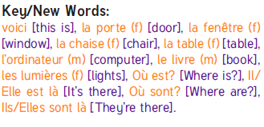  Spanish  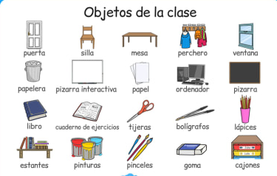 | I can ask/answer questions.  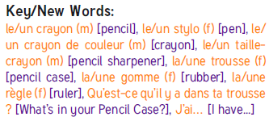  Pencil case items in Spanish  bolígrafo - pen.  lápiz - pencil.  sacapuntas - sharpener.  regla - ruler.  goma - rubber. | I can express opinions.  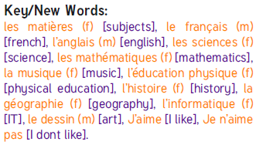  Spanish  Ciencia – Science Arte - Art  Deporte / Educación Física - Sport / Physical Education Historia - History  Matemáticas - Mathematics  Geografía - Geography  Música - Music | I can listen to and follow instructions.  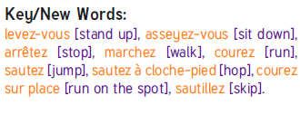 | I know the Spanish / French for familiar places.  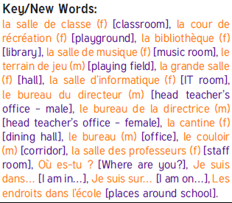
  Spanish | Pronunciation | English
  esconder | ehs-cohn-DEHR | to hide
  sentándote | sehn-TAHN-doh-tay | siting
  columpiar | koh-loom-pee-AHR | to swing
  escalando | ehs-kah-LAHN-doh | climbing
  tocando | toh-KAHN-doh | playing
  jugando | who-GAHN-doh | playing
  Spanish | Translation
  la clase | the class / classroom
  la biblioteca | the library
  la cafetería | the cafetería
  la pizarra | the whiteboard / the board

Year 5 Autumn – Spanish Focus - Getting to Know You (revisit from Year 4 autumn term)

Lesson 1 Hello | Lesson 2 What’s your name? | Lesson 3 How are you? | Lesson 4 Goodbye | Lesson 5 Numbers 0-20 | Lesson 6 How old are you?
I can say hello for different times of day.  Buenas! – Short way to say Good morning/afternoon etc.  Encantado/a or Mucho Gusto – Nice or pleased to meet you.  Adiós / Hasta luego – Goodbye / Bye.  Hasta pronto – See you soon.  Nos vemos – See you.  Cuídate! – Take care | I can introduce myself to someone else.  I can ask another person their name.  To introduce yourself, simply say "Me llamo" (may YAHM-oh) followed by your name. For example, "Hola, me llamo Chris" ("OH-la, may YAHM-oh Chris") means "Hi, I'm Chris." | .I can choose the appropriate phrase to say how they feel.  If you'd like to say “Hi, how are you?” in Spanish, you can use “Hola, ¿cómo estás?” (informal/singular). If you are greeting someone in a more formal setting, you'll want to use “Hola, ¿cómo está?” (formal/singular). | I can say goodbye in a variety of ways.  I can use formal and informal language.  Adiós / Hasta luego – Goodbye / Bye.  Hasta pronto – See you soon.  Nos vemos – See you.  Cuídate! – Take care | To say the numbers 0-15 in Spanish.  1 uno, 2 dos, 3 tres  4 cuatro, 5 cinco 6 seis, 7 siete, 8 ocho  9 nueve, 10 diez  11 once, 12 doce  13 trece, 14 catorce  15 quince, 16 dieciséis  17 diecisiete  18 dieciocho  19 diecinueve  20 veinte | I can ask how old someone is.  I can say my own age.  I can use number words in my sentences.  verb tener  In Spanish, we use the verb tener (to have) to talk about age. To say I am [number] years old, we use tengo + [number of years] + años. Yo tengo veintiséis años. I am twenty-six years old.

Year 5 Spring – French Focus / Time

Lesson 4 What colour is it? | Lesson 2 Days of the week | Lesson 3 Months of the year | Lesson 4 Mon Anniversaire | Lesson 5 What’s the date today? | Lesson 6 Yesterday, Today, Tomorrow
I can describe colour by modifying adjectives.  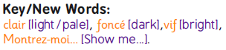 | I can ask and answer questions.  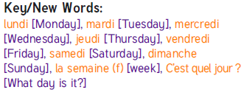 | I can ask and answer questions.  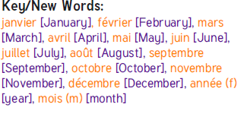 | I can ask and answer questions.  I can say my date of birth.  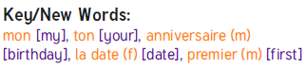 | I can use known language linked to festival dates.  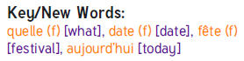 | I can know the verb ‘to be’ for past and future.  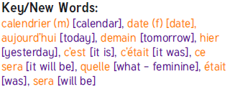

Year 5 Summer – Spanish / French Focus

Lesson 1 My pets | Lesson 2 My Body | Lesson 3 Actions | Lesson 4 Colours | Lesson 5 Clothes: What’s in your wardrobe? | Lesson 6 Clothes: What’s in your wardrobe?
I can use gestures to help me remember the vocabulary.  Spanish | To demonstrate my understanding with actions.  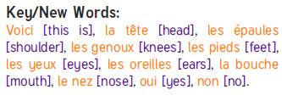  Spanish  (the) head — (la) cabeza.  (the) hair — (el) pelo.  (the) neck — (el) cuello.  (the) chest — (el) pecho.  (the) arm — (el) brazo.  (the) finger — (el) dedo.  (the) foot — (el) pie.  (the) face — (la) cara. | I can understand and respond to actions words.  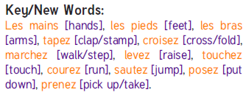  Spanish  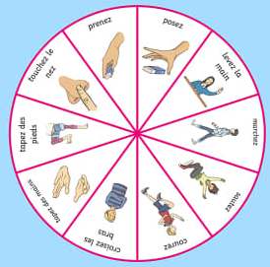 | I can name different colours in French.  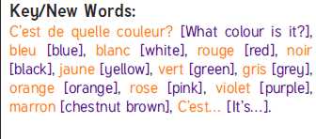  Spanish  Anaranjado - Orange.  Amarillo - Yellow.  Azul - Blue.  Blanco - White.  Morado - Purple.  Marrón, Café - Brown.  Negro - Black.  Rosado - Pink. | I can name clothes in French.  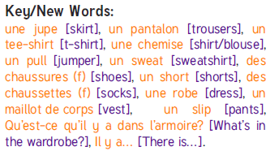 | I can name clothes in Spanish 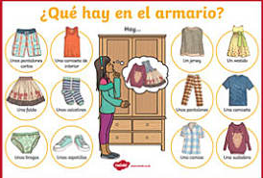

Year 6 Autumn – Spanish / French Focus - Getting to Know You (revisit from previous autumn terms)

Lesson 1 Hello | Lesson 2 What’s your name? | Lesson 3 How are you? | Lesson 4 Goodbye | Lesson 5 Numbers 0-15 | Lesson 6 How old are you?
I can say hello for different times of day.  Buenas! – Short way to say Good morning/afternoon etc.  Encantado/a or Mucho Gusto – Nice or pleased to meet you.  Adiós / Hasta luego – Goodbye / Bye.  Hasta pronto – See you soon.  Nos vemos – See you.  Cuídate! – Take care | I can introduce myself to someone else.  I can ask another person their name.  To introduce yourself, simply say "Me llamo" (may YAHM-oh) followed by your name. For example, "Hola, me llamo Chris" ("OH-la, may YAHM-oh Chris") means "Hi, I'm Chris." | .I can choose the appropriate phrase to say how they feel.  If you'd like to say “Hi, how are you?” in Spanish, you can use “Hola, ¿cómo estás?” (informal/singular). If you are greeting someone in a more formal setting, you'll want to use “Hola, ¿cómo está?” (formal/singular). | I can say goodbye in a variety of ways.  I can use formal and informal language.  Adiós / Hasta luego – Goodbye / Bye.  Hasta pronto – See you soon.  Nos vemos – See you.  Cuídate! – Take care | To say the numbers 0-15 in Spanish.  uno (ooh-no), dos (dohs), tres (trays), cuatro (kwah-troh), cinco (seen-koh), seis (says), siete (syay-tay), ocho (oh-choh), nueve (nway-vay), diez (dyays).  uno, dos, tres, cuatro, cinco, seis, siete, ocho, nueve, diez, once, doce, trece, catorce, quince | I can ask how old someone is.  I can say my own age.  I can use number words in my sentences.  verb tener  In Spanish, we use the verb tener (to have) to talk about age. To say I am [number] years old, we use tengo + [number of years] + años. Yo tengo veintiséis años. I am twenty-six years old.
Use the language in a conversational manner, partner work

Year 6 Spring – Spanish / French Focus – About me / numbers

Lesson 1 My Day | Lesson 2 | Lesson 3 Counting in tens | Lesson 4 Counting to 100 | Lesson 5 My address is | Lesson 6 How do you say?
I can write a sentence.  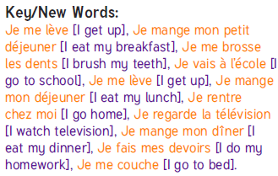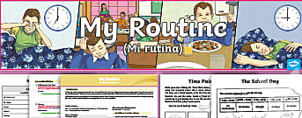  Use the language in a conversational manner, partner work |  | I can explore patterns to count in 10’s.  Cero, diez, veinte, treinta, cuarenta, cincuenta, sesenta, stenta, ochenta, noventa, cien  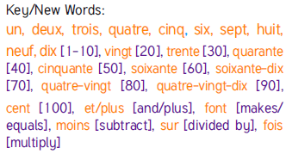 | I can explore patterns to count to 100.  Cien (see-EHN)  doscientos  (dohs-see-EHN-tohs)  trescientos  (trace-see-EHN-tohs) cuatrocientos  (kwah-troh-see-EHN-tohs)  quinientos  (key-nee-EHN-tohs)  seiscientos  (saze-see-EHN-tohs)  setecientos  (see-ay-tay-see-EHN-tohs)  ochocientos  (oh-cho-see-EHN-tohs)  novecientos  (no-veh-see-ehn-tohs) | I can select and present information to other people.  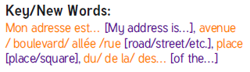  Spanish  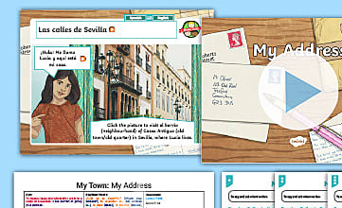 | I can sort vocabulary into topic groups.  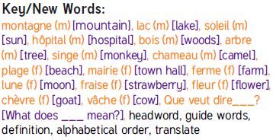

Year 6 Summer – Holidays and Hobbies
Lesson 1  Holidays – comparing French and Spanish words | Lesson 2  Sports - comparing French and Spanish words | Lesson 3  Hobbies - comparing French and Spanish words | Lesson 4 / 5/ 6  Language (country) of pupil’s choice – revisit from previous year and consolidate
I can speak a sentence about going on holiday.  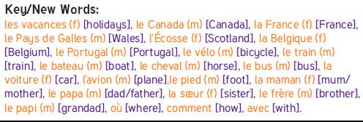  Spanish  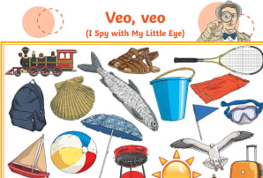 | I can answer a question about sports, orally and in writing.  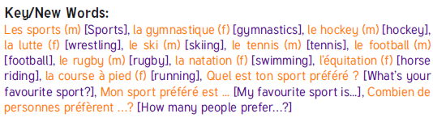  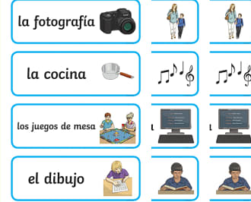 | I can answer a question about hobbies, orally and in writing.  In both Spanish and French conversations. | I can say hello for different times of day. | I can introduce myself to someone else.  I can ask another person their name. | I can say goodbye in a variety of ways.  I can use formal and informal language.

