

Communicating with Confidence

- Attune to your young person's needs
- Creating an environment for your young person to feel comfortable and safe
- Open up opportunities to encourage communication and interaction
- Building positive relationships and connections
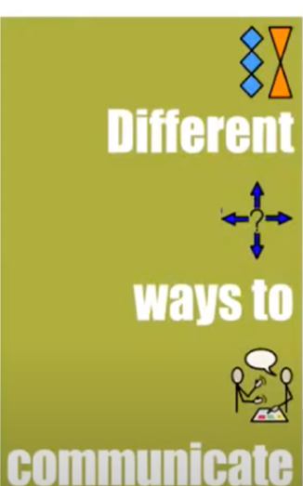

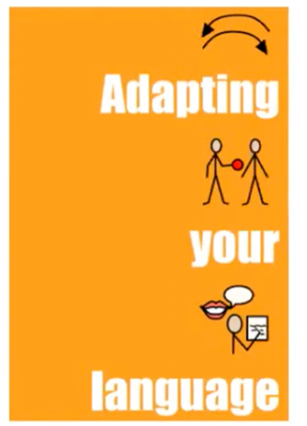

Book: ‘Is that clear?’ - https://www.amazon.co.uk/THAT-CLEAR-Effective-communication-neurodiverse/dp/1916280021

SEN support

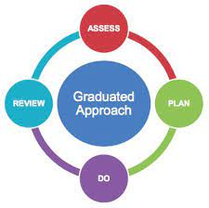
Graduated response- ‘Southend SEND: what happens next’ A ‘Graduated Response’ to Special Educational Needs and Disabilities: https://www.southendlearningnetwork.co.uk/Pages/Download/3eccd3a2-9fe3-4738-a3f8-c91d4ba296d4/PageSectionDocuments

Useful links:

Southend Psychology Service Resource Website https://www.southendlearningnetwork.co.uk/educationalpsychology

EP Connect Phone Line – This phone line is for both parents/schools and professionals to speak directly with an EP regarding quick queries. 01702 212690

Webinars
-Flipbook guide 2020 https://www.flipsnack.com/icaep/copy-of-new-flipbook.html
-Flipbook guide 2021- https://www.flipsnack.com/BB9FDB99E8C/new-flipbook.html
How to support your child in asking for help with Dr Mary Stanley-Duke https://www.youtube.com/watch?v=gZ5ZXyT4QbM&t=6s

