Land and Sea Summer Knowledge Organiser Reception - Seahorse Class
Key line of enquiry – Where would you prefer to live, inland or by the seaside? Why?
Task – Act and sing a pirate story
I can offer explanations for why things might happen, making use of recently introduced vocabulary from stories, non-fiction, rhymes, and poems when appropriate  I can work and play cooperatively and take turns with others  I can describe their immediate environment using knowledge from observation, discussion, stories, non-fiction texts and maps  I can explain some similarities and differences between life in this country and life in other countries, drawing on knowledge from stories, non-fiction texts and (when appropriate) maps  I can know some similarities and differences between things in the past and now, drawing on their experiences and what has been read in class |  |  |  |  |  |  | I can know some similarities and differences between the natural world around them and contrasting environments  I can safely use and explore a variety of materials, tools, and techniques, experimenting with colour, design, texture, form, and function  I can share their creations, explaining the process they have used  I can invent, adapt, and recount narratives and stories with peers and their teacher  I can perform songs, rhymes, poems, and stories with others, and (when appropriate) try to move in time with music.
Key questions and focus
Where is ….? What language do you think they speak?  How could you travel to….?  What is a passport?  Have you been to….?  What is the difference between a river, sea, and ocean?  What animals would you find in a farm?  What do you call baby cows etc? |  |  |  |  |  |  | What vegetables grow on a farm? What food comes from cows etc?  How can you be safe when at the beach?  What foods are healthy?  How do you stay fit?  What happens to your body when you exercise?  What is happening when you mix the colours….?  What is happening in the painting?
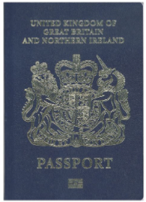
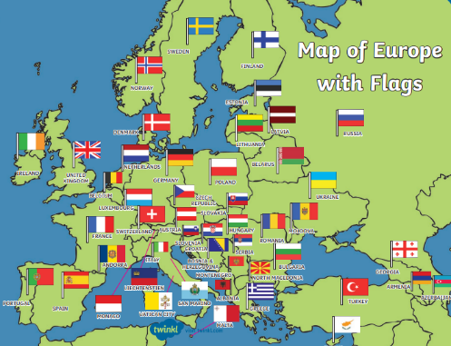
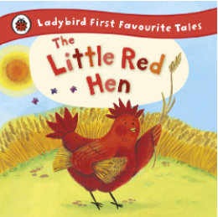
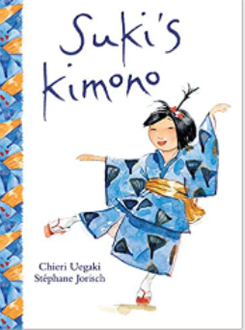
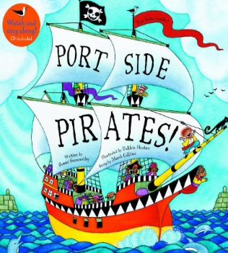
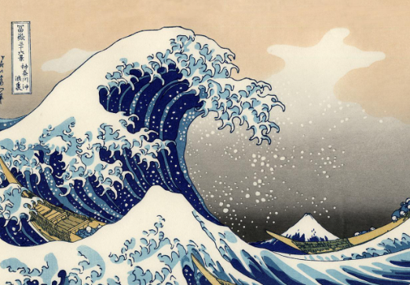

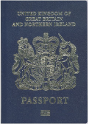

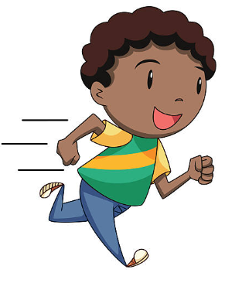
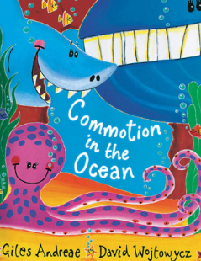
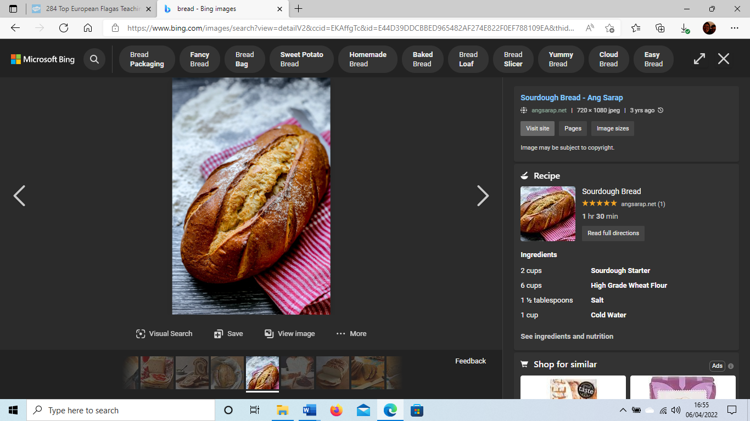
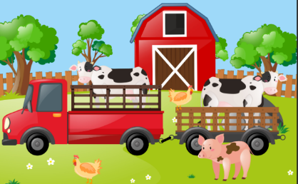
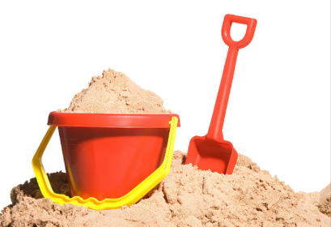
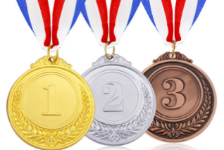

Vocabulary
Globe | A spherical model of Earth |  |  | Land |  | A part of the earth's surface that is not covered by water |  |  | Calf |  | A baby cow
Map | A flattened visual representation of a geographical area showing topographic details, buildings, and roads |  |  | Past |  | A period which has already occurred |  |  | Piglet |  | A baby pig
Voyage | A long journey to a foreign or distant place |  |  | Present |  | A period of time which is happening now |  |  | Foal |  | A baby horse
Holiday | An extended period for leisure and recreation usually away from home |  |  | Steam train |  | An old-fashioned train that used steam for power |  |  | Lamb |  | A baby sheep
Passport | A government document which shows a person’s identity and citizenship. It enables the person to travel to foreign countries |  |  | Penny farthing |  | An old-fashioned type of bicycle with a large wheel at the front and a small wheel at the back |  |  | Jolly Roger |  | A pirate's flag with white skull and crossbones on a black background
Destination | A place which someone is travelling to |  |  | Aviator |  | A person that flies an aircraft, another word for a pilot |  |  | Cutlass |  | A short sword with a slightly curved blade
River | A natural stream of fresh water flowing towards an ocean, sea, or lake |  |  | Fitness |  | Being physically fit and healthy |  |  | Galleon |  | A large, multi-decked sailing ship
Sea | A body of salt water, smaller than an ocean |  |  | Healthy |  | - Being in a good physical or mental condition  - Something that promotes good health |  |  | Compass |  | A device which indicates direction
Ocean | A very large body of salt water, covering 70% of the planet Earth |  |  | Harvest |  | The process or period of gathering in crops |  |  | Rigging |  | A system of ropes or employed to support a ship's masts
Curriculum links
Communication and language |  | PSED | Physical |  | Literacy |  |  | Mathematics |  | Understanding the world |  | Expressive art and design
*Hot seating characters from the story  *Act out a story  *Describe what is happening within the art mixing, science experiments and cooking  *Connect ideas together  *Extend our vocabulary when communicating with others  *Learn to say hello, goodbye, please and thankyou in different languages |  | *Discussing personal experiences from the weekend  *Extend teamwork in child-initiated play  *Recognise how to stay safe in different scenarios  *Understand how to be healthy  *Explore and express our emotions during transitions | *Develop overall body-strength, balance, co-ordination, and agility  *Extend control and pressure when using our fine motor skills  *Take part in swimming and PE |  | *Use our phonics to write phrases and sentences  *Continue to develop letter formation  *Add detail to our writing  *Explore rhyming words in stories  *Develop accuracy, rate, punctuation, and expression when reading |  |  | *Create number bonds to 10  *Explore place value of numbers 11 to 20  *Investigate the number pattern of numbers past 20  *Use 2D/3D shapes to construct landmarks  *Use reasoning within problem solving  *Explore halving, sharing, and doubling |  | *Visit Barley Land  *Explore European countries  *Explore the differences between land and sea  *Celebrate the Queen’s Jubilee  *Investigate transport from the past and present  *Investigate salt and ice  *Explore volcanoes  *Explore floating and sinking |  | *Colour mixing with different medias  *The great wave mural  *Create jewellery  *Act out a pirate story  *Sing songs in different languages  *Bake bread  *Create a fruit salad  *Create different modes of transport

