Marvellous Me Autumn 1 Knowledge Organiser Nursery – Starfish Class
Key line of enquiry – What marvellous things can I do?
Task – Create a self portrait
I am special  - Complete a self portrait  - Name facial features  - My feelings |  |  | My body  - Name my body parts  - Looking after myself  - Name and explore the five senses |  |  |  |  | People who help us  - Visitors from our community  - Understanding different occupations
Key questions and focus
We will celebrate the uniqueness of ourselves and others.  We will look closely at our features, be able to name them and create a self-portrait.  We will begin to understand that we may have different likes and dislikes to those of others.  We will reflect on our feelings.  Can you remember a time when you have felt happy, sad, angry or scared? |  |  | We will learn about our bodies and how they work.  We will observe the effects of activity on our bodies  Can you name some body parts?  What can we do to keep our bodies healthy?  We will explore the world around us using our five senses. |  |  |  |  | We will learn how people have different jobs.  We will learn and discuss what those jobs entail.  We will develop an interest in different occupations.  We will know who helps us at home and school.  Can you name some people who help us?
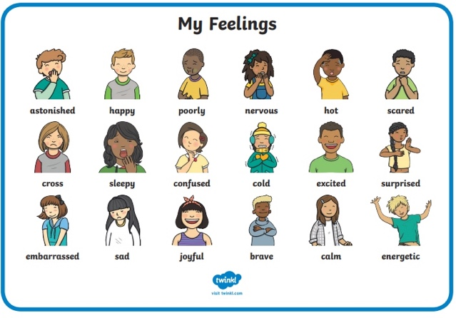 |  |  | 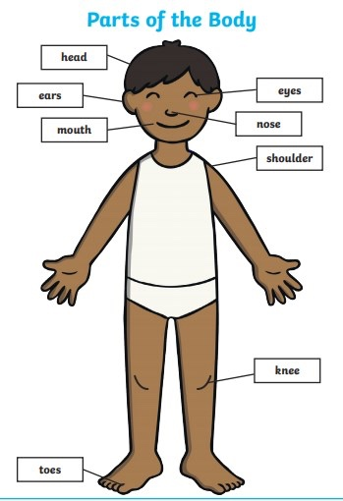 |  |  |  |  | 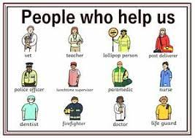
Vocabulary |  |  | Vocabulary |  |  |  |  | Vocabulary
Face parts | Hair, eyes, eyebrows, eyelashes, nose, nostrils, lips, mouth, chin, cheeks, ears | The five senses |  | See, hear, taste, smell, touch |  |  | Emergency Services |  |  | People who deal with problems
Feelings | Happy, sad, angry, excited, tired, scared, worried, surprised, embarrased | Body parts |  | Head, neck, shoulders, elbows, wrists, hands, fingers, tummy, back, hips, legs, knees, ankles, feet, toes |  |  | Ambulance |  |  | A vehicle that takes people to hospital
Unique | One of a kind | Exercise |  | Moving to keep our bodies fit and healthy |  |  | Fire Engine |  |  | Vehicle that has lots of equipment to help put out fires
Different | Not the same | Healthy |  | Well, not ill or sick |  |  | Hospital |  |  | A large building where people go to get better
Similar | Almost the same | Germs |  | Bacteria that can make us ill |  |  | Community |  |  | All the people who live in a particular area
Identical | Exactly the same | Skeleton |  | The bones that are inside our bodies |  |  | Emergency |  |  | A serious or dangerous event
Self portrait | Making a picture of ourselves | Heart |  | An organ inside our bodies that pumps our blood |  |  | Rescue |  |  | Saving someone in danger
 |  | lungs |  | An organ inside our bodies that helps us breathe |  |  | Assistance |  |  | Help or support
Curriculum links
Communication and language | PSED | Physical |  |  | Literacy | Mathematics |  |  | Understanding the world |  | Expressive art and design
- Developing communication skills.  - Understanding questions and use a wider vocabulary | - Talk about own feelings and understand the feelings of others.  - Develop increasing confidence in new social situations.  PSHE/RSE - A Spiral Curriculum link | - Be increasingly confident in self-help and self-care needs.  - Make healthy choices about food drink, activity and toothbrushing. |  |  | - Develop an understanding and awareness of print | - Begin to describe a sequence of events |  |  | - Use the 5 senses in exploration.  - Talk about what is seen using a wide vocabulary  - Show interest in different occupations  - Develop positive attitudes towards the differences between people |  | - Draw with increasing complexity and detail.  - Take part in pretend play

