Hinguar Primary School and Nursery - SECAT
Knowledge Organiser
History | Year Three | Summer Term |  | Topic: Mayans
Prior Knowledge |  | Application of Knowledge
- Used the language of time e.g. decade, century, millennium  - Made simple observations about sources  - Asked questions based on sources, core knowledge and comparisons to other periods of history  - Use a range of sources including documents, artefacts, databases and historical buildings  - Name primary and secondary sources. |  | - Order significant events and periods of time on a timeline, specifically the Ancient Mayan era.  - Use vocabulary connected to the measuring of time e.g. Century, A.C./B.C.  - Use a range of sources including photographs, reconstructions, virtual tours and artefact replicas.  - How to use inference to interpret sources.  - There are different accounts of history.  - Key facts relating to significant individuals, events, periods of time and civilisations and know the impact of these.
What will I know by the end of this topic? |  | Key Vocabulary
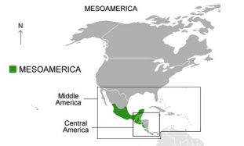  - Where did the Ancient Mayans live?  - How and when did Europeans encounter the Mayan civilisation?  - How do we know about the Mayan  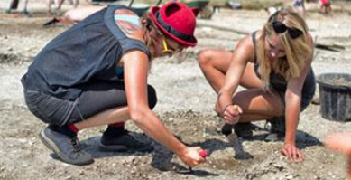  civilisation and their way of life?  - How was Mayan society organised and how this compares to modern society?  - What did the Maya believe in?  - What was daily life like for the Maya?  - What were the achievements of the Maya?  - What were the reasons behind the decline of the Mayan civilisation? |  | Maya | Indigenous people of Mexico and Central America
 |  | Mayan | a large family of languages spoken in Central America and Mexico
 |  | Mesoamerica | Mesoamerica is an historical region and  cultural area in North America.
 |  | Civilisation | human society with its well developed social organizations, or the culture and way of life of a society or country at a particular period in time
 |  | Spanish Conquistadors | Spanish people who travelled to America in the 16th century and took control of Mexico and Peru
 |  | Europeans | People in Europe
 |  | Archaeologists | Someone who studies the buildings, graves, tools, and other objects of people who lived in the past
 |  | terracing | steps built into sloping land
 |  | astronomer | someone who studies stars and planets
 |  | ceremony | a formal event at which special things are done
 |  | glyphs | Symbols used in the Mayan writing  system. Each symbol represents a word or sound.
 |  | irrigation | supplying land with water
 |  | sacrifice | to kill an animal or person in a religious ceremony


