Hinguar Primary School and Nursery - SECAT
Knowledge Organiser
History | Year 2 | Summer Term | Topic: Beachcombers
Prior Knowledge |  | Application of Knowledge
- I know that we live in the 21st Century  - I know that that there are reasons why people in the past acted as they did.  - I know that London has been a city for hundreds of years  - I know that that their own lives are different from lives of people in the past.  - I can place events on a simple timeline |  | - Identify things that are the same and things that are different between the Victorian era and now  - I can place the dates of Mary Anning’s discoveries on a simple timeline  - Write a postcard or a letter imagining that I am staying in Lyme Regis  - Write a biography of Mary Anning
What will I know by the end of this topic? |  | Key Vocabulary
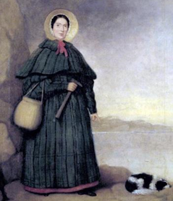  - Who is Mary Anning and why is she famous?  - When and where did Mary Anning live?  - What is a fossil and what does prehistoric mean?  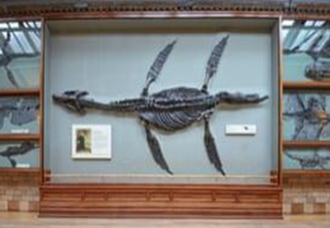  - What is her most famous discovery?  - Why did Mary not join the geological society?  - What did Mary help prove?  - How can I show what I have learned about the Mary Anning? |  | fossil | The hard remains of a prehistoric animal or plant that are found inside a rock
 |  | coastline | The land that is next to the sea
 |  | dinosaur | Large reptiles which lived in prehistoric times.
 |  | prehistoric | The time in history before any information was written down
 |  | science | Knowledge about the natural world that is based on facts learned through experiments and observation
 |  | Jurassic coast | the name of the coast where Mary Anning made a lot of her discoveries. It is in the south of England.
 |  | Lyme Regis | A seaside town on the Jurassic Coast
 |  | Victorian | during the reign of Queen Victoria (1837 – 1901)
 |  | palaeontology | the study of fossils as a guide to the history of life on Earth

