Hinguar Primary School and Nursery - SECAT
Knowledge Organiser
Religious Education |  | Nursery |  | Spring | Big Question Which stories are special and why?
Prior Knowledge |  |  |  | Application of Knowledge
You should be familiar with a range of stories. These may be from a variety of cultures and beliefs.  Key Hinge Questions  - Which stories are special to you?  - What is your favourite story?  - Are all stories true?  - Which religious stories do you know? |  |  |  | 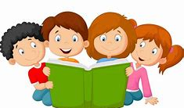  - Explore stories children like.  - Talk about the Bible being the Christians’ holy book which helps them to learn more about God.  - Hear and explore stories from the Bible, stories Jesus told and stories from the life of Jesus.  - Hear a selection of stories taken from major faith traditions and cultures.  - Explore stories through role play, model-making, puppets, art, dance and music.  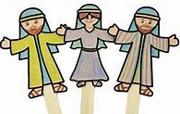
Some Special Stories
The Reward | The Crying Camel |  | The Good Samaritan
What will I know by the end of this topic? |  |  |  | Key Vocabulary
I can talk about some religious stories.  I can recognise some religious words (e.g. about God).  I can identify some of my feelings in the stories I hear.  I can identify a sacred text.  I can talk about what Jesus teaches about keeping promises and say why keeping promises is a good thing to do.  I can talk about what Jesus says about saying thank you and why it is good to be thanked. |  |  |  | Celebration |  | Bible
 |  |  |  | Tradition |  | Festival
 |  |  |  | Promise |  | Thank You

