Knowledge Organiser – Year 6 – PSHE/RSE
– Relationships – What will change as we become more independent?
How do friendships change as we grow?
– Different relationships, changing and growing, adulthood, independence, moving to secondary school
What do I already know? | What should I be able to do at the end of the topic?
- Our bodies have many different parts that have different jobs. Throughout puberty, our bodies go through several different changes. We also go through emotional changes.  - There are lots of different and interesting people to get to know in the world, and this is a good thing! We should always try to treat everyone with kindness and respect.  - There are many characteristics of strong friendships, which we should work at in order to maintain relationships.  - The things that we read and see in the media about different people and groups is not always true. We should avoid stereotyping people. Gender stereotyping is particularly common.  - Our behaviour can help us to ensure that we are valuing others. It is important to have mutual respect and tolerance for other people – understanding and respecting that some views differ from your own. | What should I be able to do at the end of the topic?
- That people have different kinds of relationships in their lives, including romantic or intimate relationships
- That people who are attracted to and love each other can be of any gender, ethnicity or faith; the way couples care for one another
- That adults can choose to be part of a committed relationship or not, including marriage or civil partnership
- That marriage should be wanted equally by both people and that forcing someone to marry against their will is a crime
- How puberty relates to growing from childhood to adulthood
- About the reproductive organs and process – how babies are conceived and born and how they need to be cared for
- That there are ways to prevent a baby being made
- How growing up and becoming more independent comes with increased opportunities and responsibilities
- How friendships may change as I grow and how to manage this
- How to manage change, including moving to secondary school; how to ask for support or where to seek further information and advice regarding growing up and changing
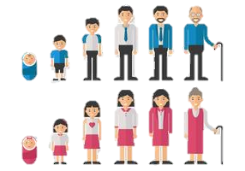
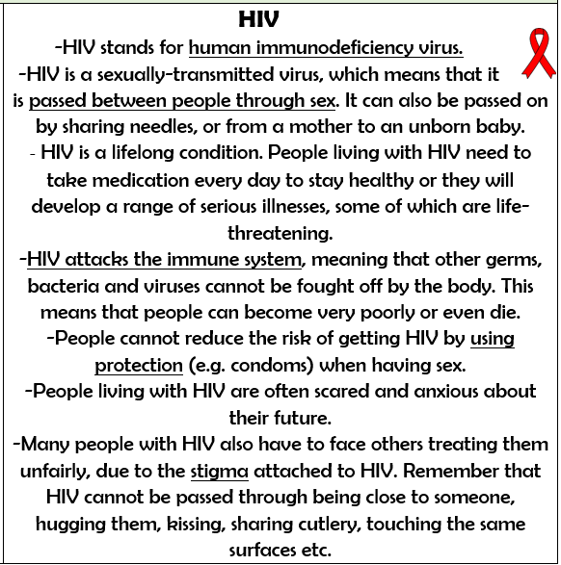
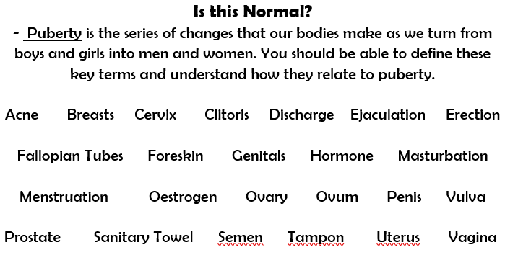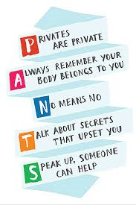

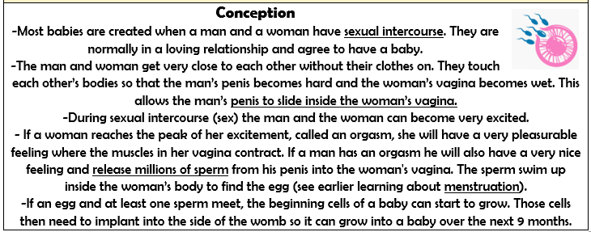

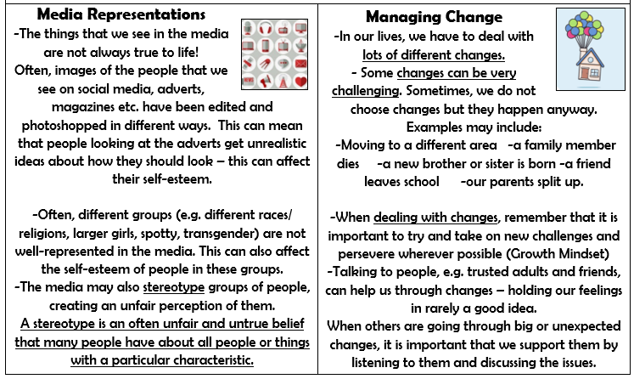

Key Vocabulary

