Knowledge Organiser – Year 6 – PSHE/RSE
– Living in the Wider World – How can the media influence people?
– Media literacy and digital resilience; influences and decision-making; online safety
What do I already know? | What should I be able to do at the end of the topic?
- I can name a variety of ways to communicate online  - I can name a variety of social networking sights  - I know to be careful when putting personal information online  - I understand when not to share personal photos online  - I understand that people I meet online might not be who they claim to be  - We have a responsibility to keep ourselves and others safe and healthy. Rules and laws are agreed responsibilities that we have in society to keep ourselves and others safe.  - Social Media can be a great tool for communication, but we need to be wary that we shouldn’t believe everything that we read online.  - We should understand the ideas of fact, fiction, opinion and bias. | What should I be able to do at the end of the topic?
- How the media, including online experiences, can affect people’s wellbeing – my thoughts, feelings and actions
- That not everything should be shared online or social media and that there are rules about this, including the distribution of images
- That mixed messages in the media exist (including about health, the news and different groups of people) and that these can influence opinions and decision
- How text and images can be manipulated or invented; strategies to recognise this
- To evaluate how reliable different types of online content and media are, e.g. videos, blogs, news, reviews, adverts
- To recognise unsafe or suspicious content online and what to do about it
- How information is ranked, selected, targeted to meet the interests of individuals and groups, and can be used to influence them
- How to make decisions about the content I view online or in the media and know if it is appropriate for my age range
- How to respond to and if necessary, report information viewed online which is upsetting, frightening or untrue
- To recognise the risks involved in gambling related activities, what might influence somebody to gamble and the impact it might have
- To discuss and debate what influences people’s decisions, taking into consideration different viewpoints
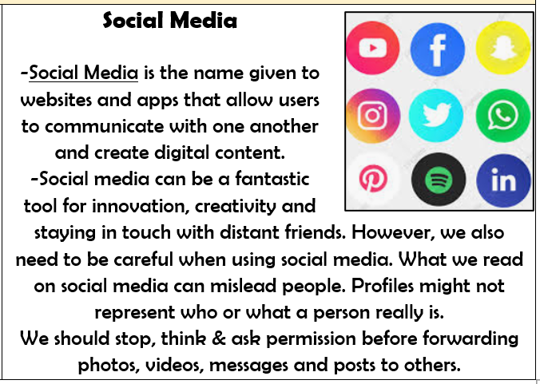
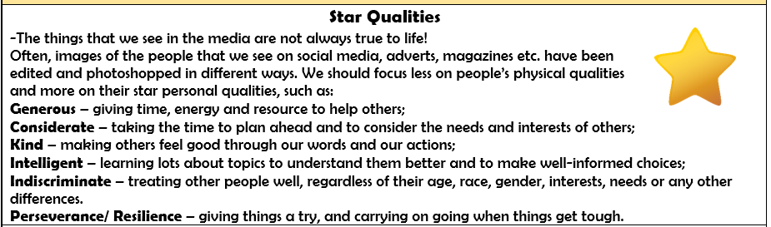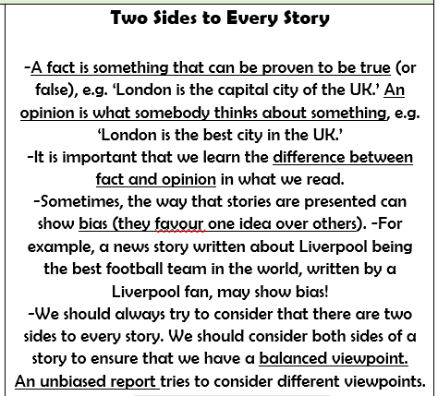
Key Vocabulary




