Knowledge Organiser – Year 6 – PSHE/RSE
– Health and Wellbeing – How can we keep healthy as we grow?
– Looking after ourselves; growing up; becoming independent; taking more responsibility
What do I already know? | What should I be able to do at the end of the topic?
- Learning is how we learn to do new things, and it is not always easy. To be at our best, we should try to live healthily, understand our bodies, and help ourselves and one another.
- We should look to develop our ‘star’ personal qualities, e.g. being kind and considerate. We should also set our own targets to help us reach our aspirations.
- Our bodies and minds are amazing and we need to look after them. There are many things that we need to do in order to keep our bodies and minds fit and healthy.
- Being healthy is about feeling good in your body and wellbeing is about feeling good in your mind. Our relationships with other people are important for our health, wellbeing and happiness.
- Habits are repeated behaviours, which can be positive or negative. When a person loses control of a habit, they can become an addiction. Many things can be addictive, including some drugs and alcohol.
- All people have emotional needs that we would like to be met. Recognising these helps us to become confident and secure individuals. We should also learn to become independent and responsible.
- How mental and physical health are linked
- How positive friendships and being involved in activities such as clubs and community groups support wellbeing
- How to make choices that support a healthy, balanced lifestyle including:
- How to plan a healthy meal
- How to stay physically active
- How to maintain good dental health, including oral hygiene, food and drink choices
- How to benefit from and stay safe in the sun
- How and why to balance time spent online with other activities
- How sleep contributes to a healthy lifestyle; the effects of poor sleep; strategies that support good quality sleep
- How to manage the influence of friends and family on health choices
- That habits can be healthy or unhealthy; strategies to help change or break an unhealthy habit or take up a new healthy one
- How legal and illegal drugs (legal and illegal) can affect health and how to manage situations involving them
- How to recognise early signs of physical or mental ill-health and what to do about this, including whom to speak to in and outside school
- That health problems, including mental health problems, can build up if they are not recognised, managed, or if help is not sought early on
- That anyone can experience mental ill-health and to discuss concerns with a trusted adult
- That mental health difficulties can usually be resolved or managed with the right strategies and support
- That FGM is illegal and goes against human rights; that they should tell someone immediately if they are worried for themselves or someone else
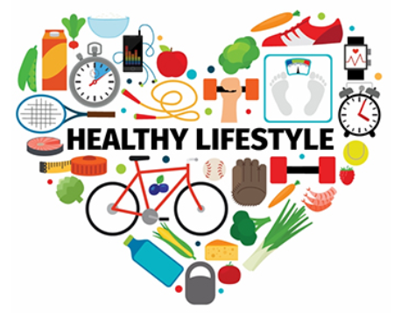
Key Vocabulary

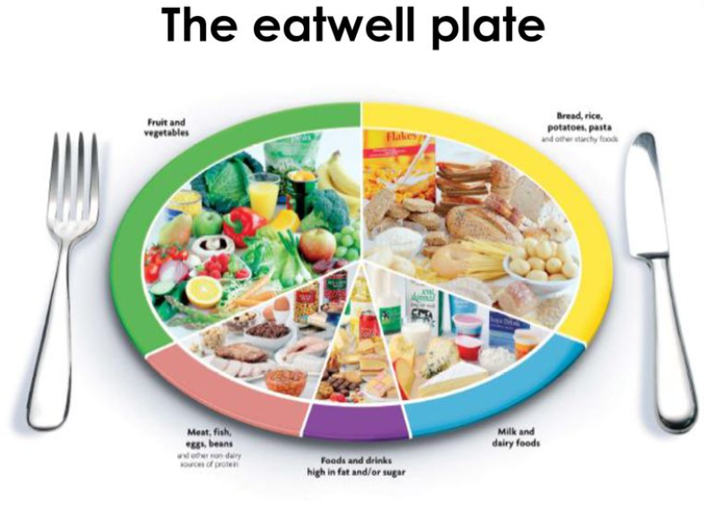  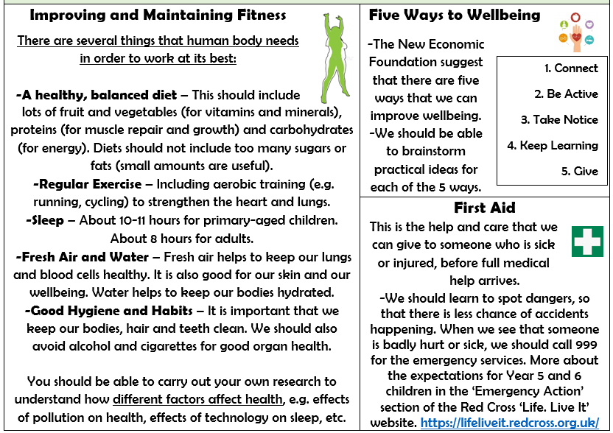  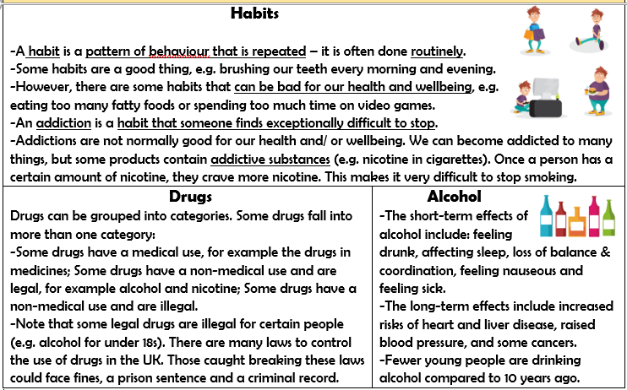 |  | 

