Knowledge Organiser – Year 5 – PSHE/RSE
– Living in the Wider World – What jobs would we like?
– Careers; aspirations; role models; the future
What do I already know? | 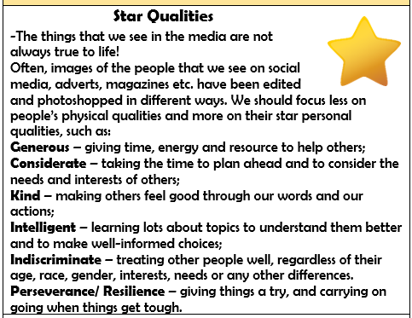  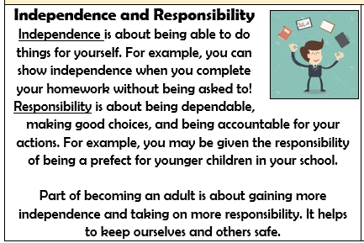  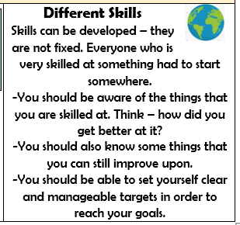
- As we get older, we should aim to develop our independence and responsibility in order to become fully-functional adults in society. We should plan towards improving our own skillsets.
- We should have an idea of our own interests and skills and identify future career possibilities
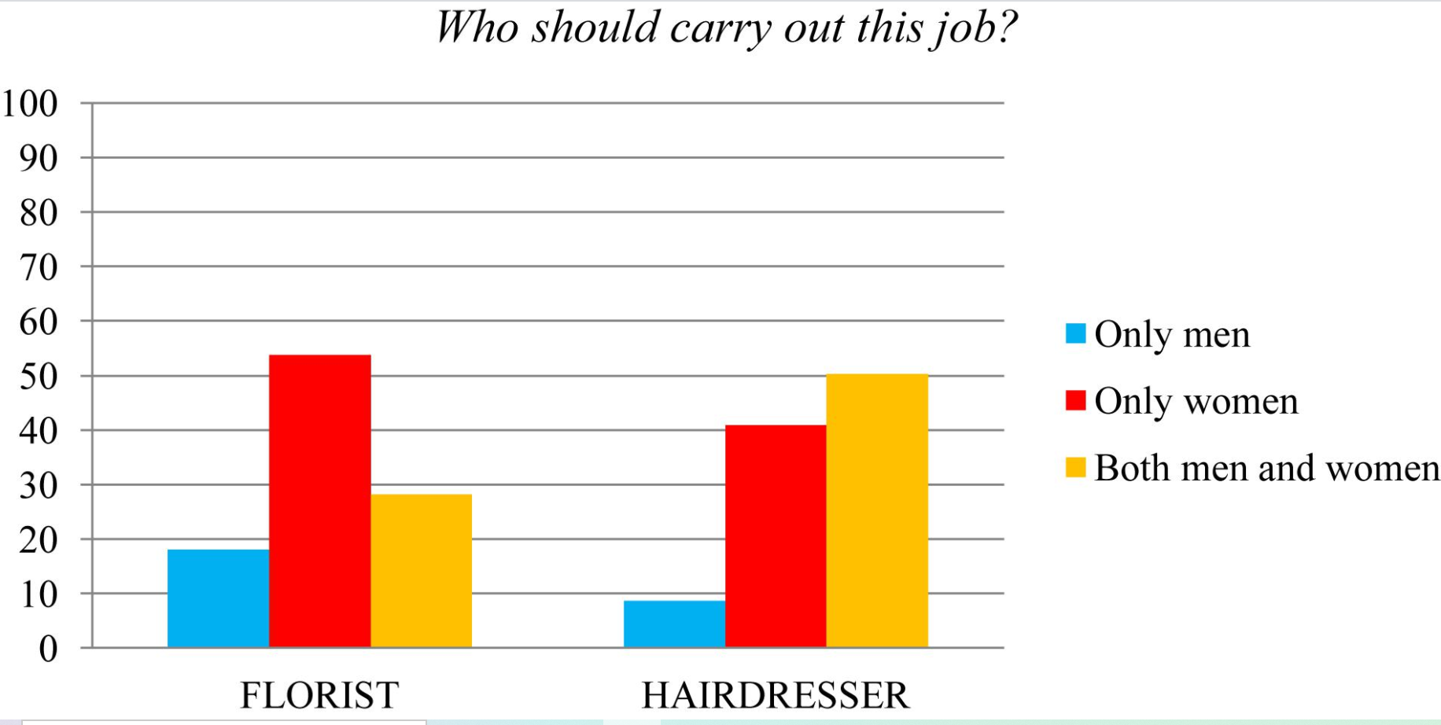

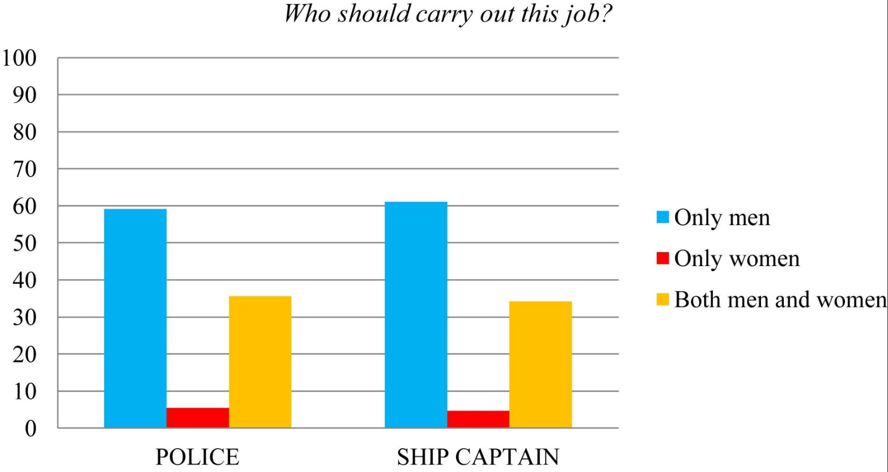

What should I be able to do at the end of the topic?
- that there is a broad range of different jobs and people often have more than one during their careers and over their lifetime
- that some jobs are paid more than others and some may be voluntary (unpaid)
- about the skills, attributes, qualification and training needed for different jobs
- that there are different ways into jobs and careers, including college, apprenticeships and university
- how people choose a career/job and what influences their decision, including skill, interest and pay
- how to question and challenge stereotypes about the types of jobs people can do
- how I might choose a career/job for myself when I am older, why I could choose it and what might influence my decisions
 | Key Vocabulary

