Knowledge Organiser – Year 5 – PSHE/RSE
– Health and Wellbeing – How can drugs common to everyday life affect health?
– Drugs, alcohol and tobacco; healthy habits
What do I already know? | 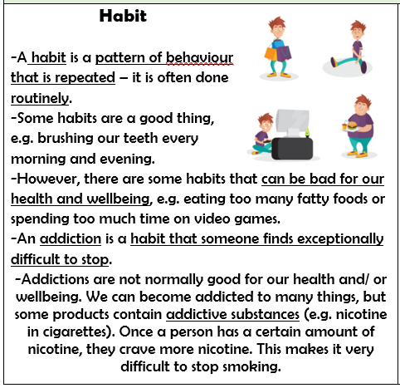  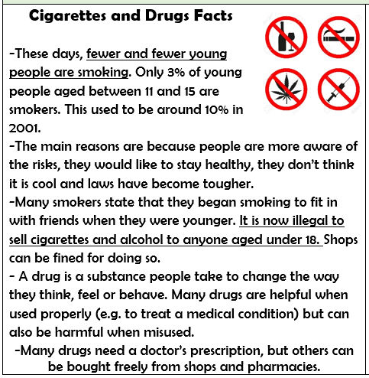
- Being healthy is about feeling good in your body and wellbeing is about feeling good in your mind. Our relationships with other people are important for our health, wellbeing and happiness.
- Habits are repeated behaviours, which can be positive or negative. When a person loses control of a habit, they can become an addiction. Many things can be addictive, including some drugs.
- In order to solve dilemmas, we should take active steps to consider the risks of each option. We should understand that taking some risks can be a good thing and we can ask a trusted adult if we are unsure.
- We do not have to do things that we are uncomfortable with
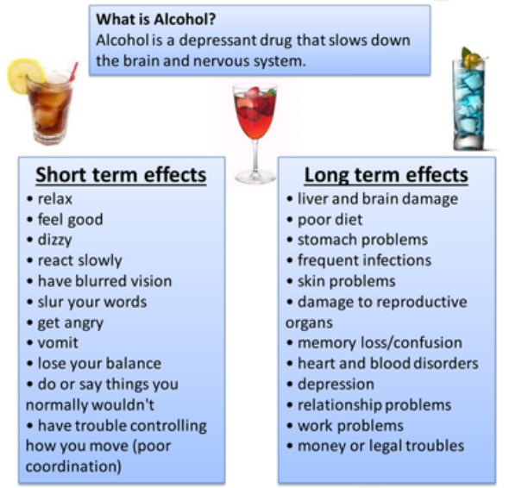
What should I be able to do at the end of the topic?
- how drugs common to everyday life (including smoking/vaping – nicotine, alcohol, caffeine and medicines) can affect health and wellbeing
- that some drugs are legal (but may have laws or restrictions related to them) and other drugs are illegal
- how laws surrounding the use of drugs exist to protect me and others
- why people choose to use or not use different drugs
- how people can prevent or reduce the risks associated with them
- that for some people, drug use can become a habit which is difficult to break
- how organisations help people to stop smoking and the support available to help people if they have concerns about any drug use
- how to ask for help from a trusted adult if I have any worries or concerns about drugs
 | Key Vocabulary

