Knowledge Organiser – Year 5 – PSHE/RSE
– Relationships – How can friends communicate safely?
– Friendships; relationships; becoming independent; online safety
What do I already know? | 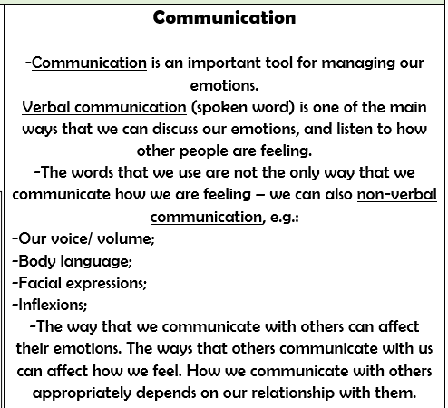  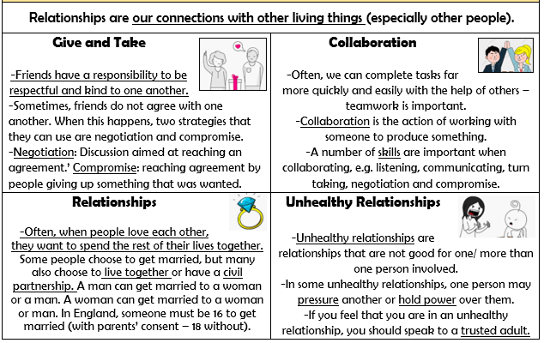
- There are special people in our lives, who can help us feel happy and safe. We have a responsibility to be kind and respectful to the special people in our lives.
- We have many different emotions. We can affect the emotions of ourselves and others through our thoughts, words and actions. Different people may feel differently about the same thing.
- We know that things posted online might not be private0
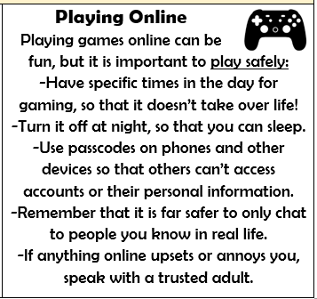
What should I be able to do at the end of the topic?
- about the different types of relationships people have in my life
- how friends and family communicate together; how the internet and social media can be used positively
- how knowing someone online differs from knowing someone face-to-face
- how to recognise risk in relation to friendships and keeping safe
- about the types of content (including images) that is safe to share online; ways of seeking and giving consent before images or personal information is shared with friends or family
- how to respond if a friendship is making me feel worried, unsafe or uncomfortable
- how to ask for help or advice and respond to pressure, inappropriate contact or concerns about personal safety
 | Key Vocabulary

