Knowledge Organiser – Year 5 – PSHE/RSE
– Health and Wellbeing – How can we help in an accident or emergency?
– Basic first aid, accidents, dealing with emergencies
What do I already know? | 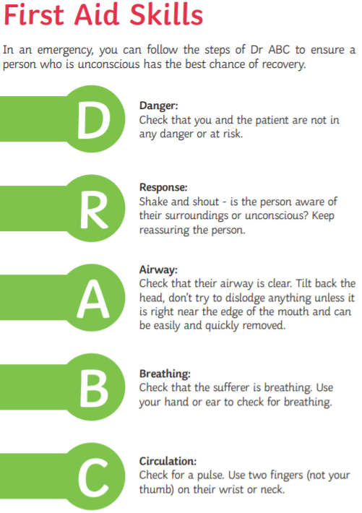  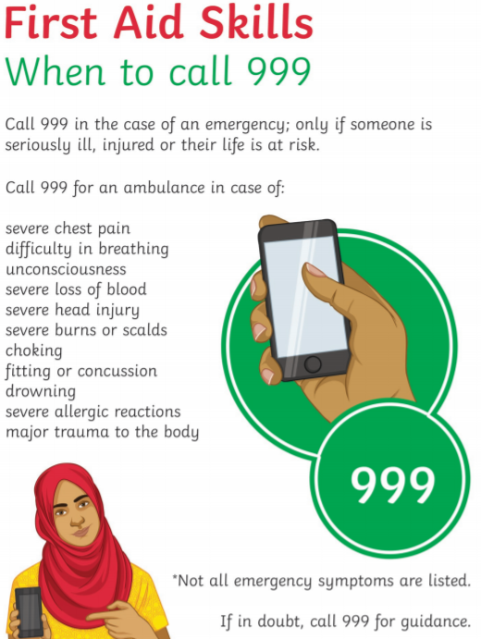
- I know who I can talk to if I or someone else is ill or has an accident
- I know to ring 999 to call the police, the fire brigade or paramedics
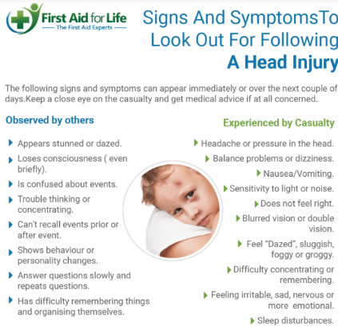
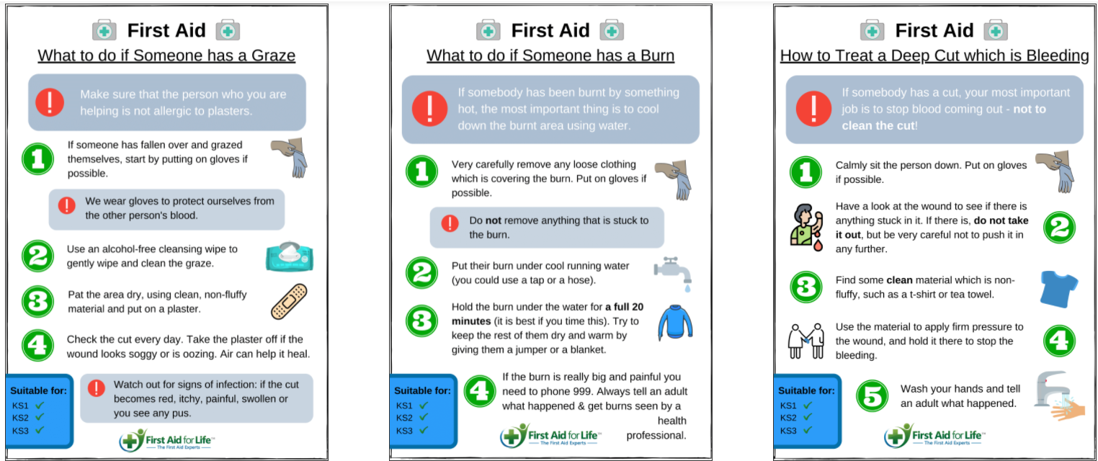

What should I be able to do at the end of the topic?
- how to carry out basic first aid including for burns, scalds, cuts, bleeds, choking, asthma attacks or allergic reactions
- that if someone has experienced a head injury, they should not be moved
- when it is appropriate to use first aid and the importance of seeking adult help
- the importance of remaining calm in an emergency and providing clear information about what has happened to an adult or the emergency services

