Knowledge Organiser – Year 5 – PSHE/RSE
– Living in the Wider World – What decisions can people make with money?
– Money; making decisions; spending and saving
What do I already know? | 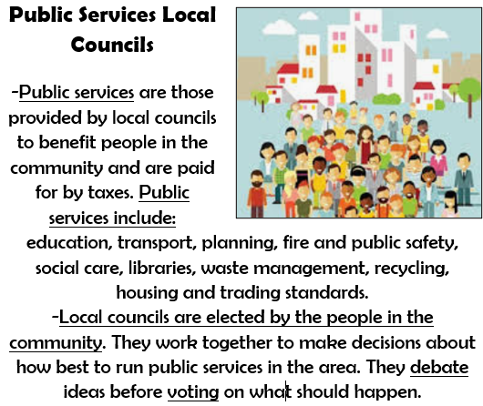  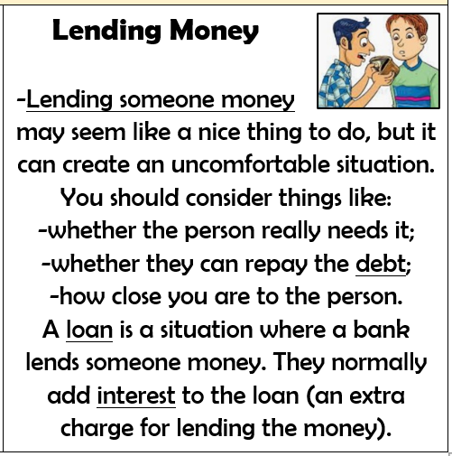  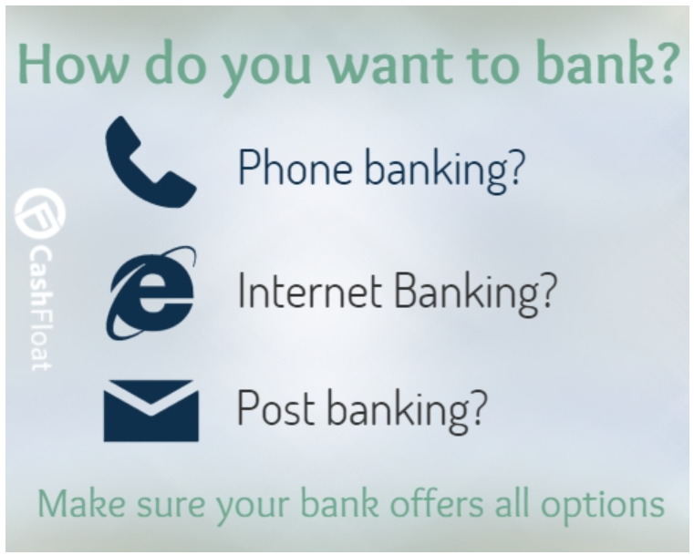
- How jobs help people earn money to pay for things they need and want
- That
- We should remember that products are designed to make money, and we should spend our money wisely.
- We should also be careful about lending money to others.
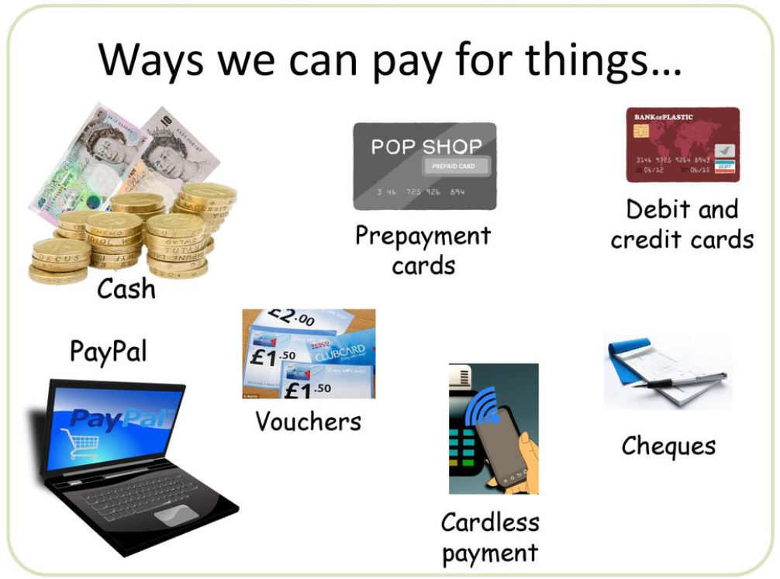

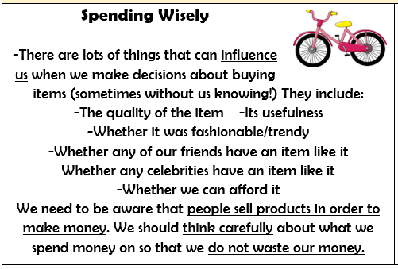
What should I be able to do at the end of the topic?
- how people make decisions about spending and saving money and what influences them
- how to keep track of money so people know how much they have to spend or save
- how people make choices about ways of paying for things they want and need (e.g. from current accounts/savings; store card/ credit cards; loans)
- how to recognise what makes something ‘value for money’ and what this means to me
- that there are risks associated with money (it can be won, lost or stolen) and how money can affect people’s feelings and emotions
 | Key Vocabulary

