Knowledge Organiser – Year 5 – PSHE/RSE
– Health and Wellbeing – What makes up our identity?
– Identity; personal attributes and qualities; similarities and differences; individuality; stereotypes
What do I already know? | 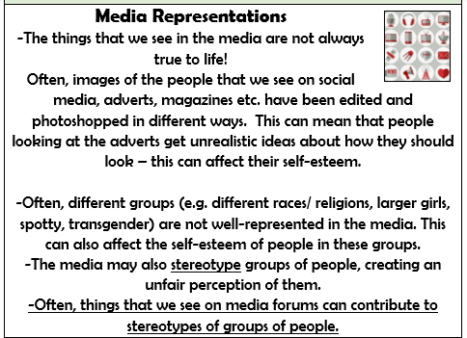  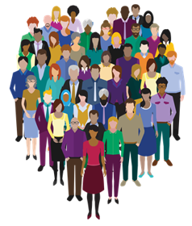  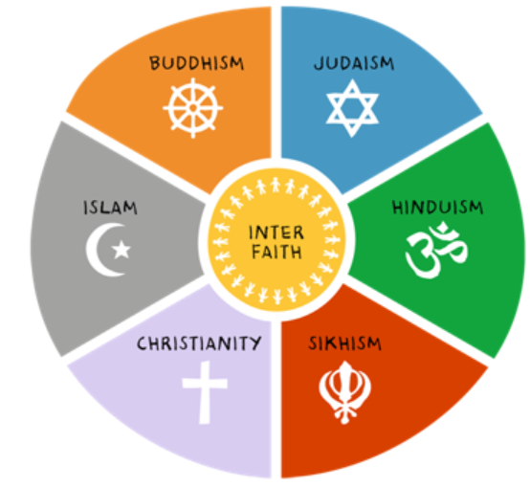  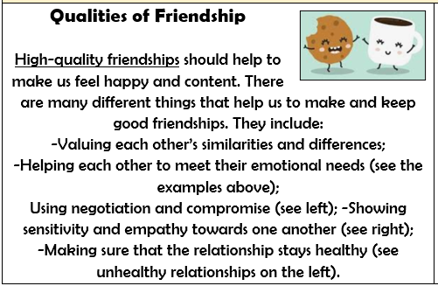
- How to recognise personal qualities and individuality
- To develop self-worth by identifying positive things about myself and my achievements
- How my personal attributes, strengths, skills and interest contribute to my self-esteem
- How to set goals for myself
- How to manage when there are set-backs, learn from mistakes and reframe unhelpful thinking
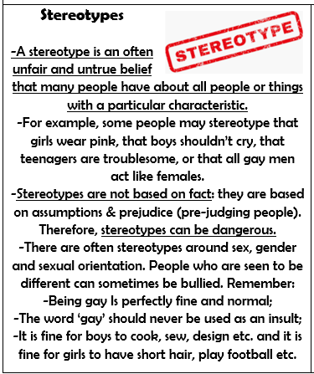
What should I be able to do at the end of the topic?
- how to recognise and respect similarities and differences between people and what I have in common with others
- that there are a range of factors that contribute to a person’s identity (e.g. ethnicity, family, faith, culture, gender, hobbies, likes/dislikes)
- how individuality and personal qualities make up someone’s identity (including that gender identity is part of personal identity and for some people does not correspond with their biological sex)
- about stereotypes and how they are not always accurate, and can negatively influence behaviours and attitudes towards others
- how to challenge stereotypes and assumptions about others
 | Key Vocabulary

