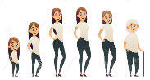
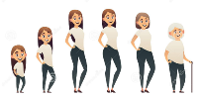
GROWING AND CHANGING
Y5 PSHE
KNOWLEDGE ORGANISER
Overview and Recap |  |  | Knowing Our Bodies
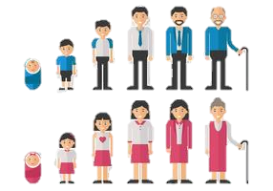  Growing and Changing  We are learning about our bodies and our relationships with ourselves and others. We are focusing on how these things grow and change over time.  You should already know that: Our bodies have many different parts that have different jobs. Throughout puberty, our bodies go through several different changes. We also go through emotional changes.  -It is important that we do not stereotype people based on assumptions and beliefs. Stereotyping people can be dangerous.  -Throughout puberty, our bodies change in lots of different ways. We should have an increasing understanding of the names and functions of different body parts.  -We may also have mood swings and become embarrassed more easily. This can be a good thing as long as we (and others) react in the correct way. |  |  | 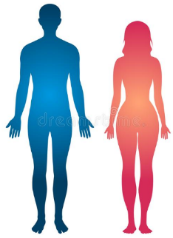  Changing Body Parts  - Puberty is the series of changes that our bodies make as we turn from boys and girls into men and women.  - Puberty starts between ages 8 and 13 in girls and ages 9 and 15 in boys. At this age, young people will become aware of changes that are taking place to their bodies. You should be able to identify more parts of the body and features of puberty:  Acne Anus Balls Bra Breasts Cervix Clitoris  Deodarant Discharge Ejaculation Erection Emotions  Fallopian Tubes Foreskin Friends Growth Genitals  Hair Hygiene Hormone Masturbation Menstruation  Oestrogen Ovary Ovum Period Puberty Penis  Prostate Pubic Relationships Sanitary Towel Semen  Scrotum Tampon Testicles Uterus Vagina Vulva |  |  | 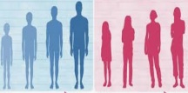  Puberty and Feelings  Puberty starts when hormones are triggered by the brain. Hormones also affect our mood and our feelings. This can make a young person think and feel different. They may want to be more independent and think about adulthood.  -Young people should learn what their different feelings are, e.g. anxiety, anger, disappointment.  -They should take appropriate steps to manage their feelings, e.g. speaking with a trusted adult, breathing techniques, making a pros and cons list, etc.  -Remember that you should always treat other people with kindness and respect, even when you are having a difficult day!
Healthy Relationships
Relationships are our connections with other living things.
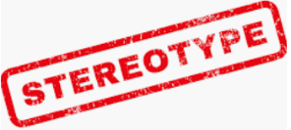  Stereotypes  -A stereotype is an often unfair and untrue belief that many people have about all people or things with a particular characteristic.  -For example, some people may stereotype that girls wear pink, that boys shouldn’t cry, that teenagers are troublesome, or that all gay men act like females.  -Stereotypes are not based on fact: they are based on assumptions & prejudice (pre-judging people). Therefore, stereotypes can be dangerous.  -There are often stereotypes around sex, gender and sexual orientation. People who are seen to be different can sometimes be bullied. Remember:  -Being gay Is perfectly fine and normal;  -The word ‘gay’ should never be used as an insult;  -It is fine for boys to cook, sew, design etc. and it is fine for girls to have short hair, play football etc. |   Embarrassment  -During puberty, young people often become more aware of what the people around them think.  -The thoughts of their peers can become particularly important to us at this time.  -This can mean that there are more times where we may feel embarrassed about things that didn’t used to bother us as much. Some examples may include:  Falling over Not knowing an answer in class  Someone calling teacher ‘mum’ Sitting alone  -How other people react to us in times of embarrassment can really help us to feel more comfortable. Some things that they can do include talking to them or letting a trusted adult know.  -However, remember that it may be overwhelming for too many people to help someone at the same time.
 |  |  | RSE Content
 |  |  |   Secrets and Surprises  -A surprise is when something happens that someone wasn’t expecting. A secret is when someone tells us not to tell something. Secrets can sometimes be bad. We don’t have to keep secrets if they make us feel uncomfortable. Our bodies can tell us when secrets are bad (e.g. feeling sick, going red).  We may feel uncomfortable ‘breaking confidence’ with someone, but it is the right thing to do when it is unsafe.  There are lots of different people who we can turn to when we feel uncomfortable. These include:  Parent or care Other family members Teacher  Teaching assistant Headteacher Friends Childline |  |  | 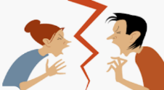  Conflict  -During puberty, hormones can cause our emotions to change very quickly. This can lead to mood swings and conflict.  -We may argue more with those around us, including parents, siblings and friends. It is important to find compromises using kindness and respectful/courteous language.

Egg
Marriage
Surprise
Key Vocabulary
Fertilisation
Period
Menstruation
Relationship
Womb
Secret
Personal
Physical
Emotional
Puberty

