Knowledge Organiser – Year 4 – PSHE/RSE
– Health and Wellbeing – How can we manage risk in different places?
– Keeping safe; out and about; recognising and managing risk
What do I already know? | 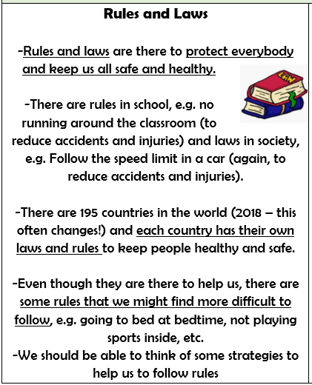  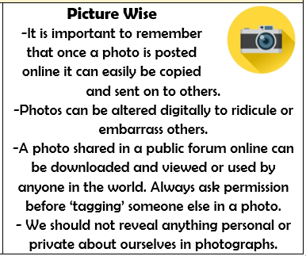
- We have a responsibility to follow the rules and laws of our society.
- We have a responsibility to keep ourselves and others safe.
- In order to keep ourselves safe, we should understand dangerous situations – recognising the dangers, hazards and risks. We should think ahead in order to manage risks.
- There are some people who can help to keep us healthy and safe. We can help them to help us and other people.
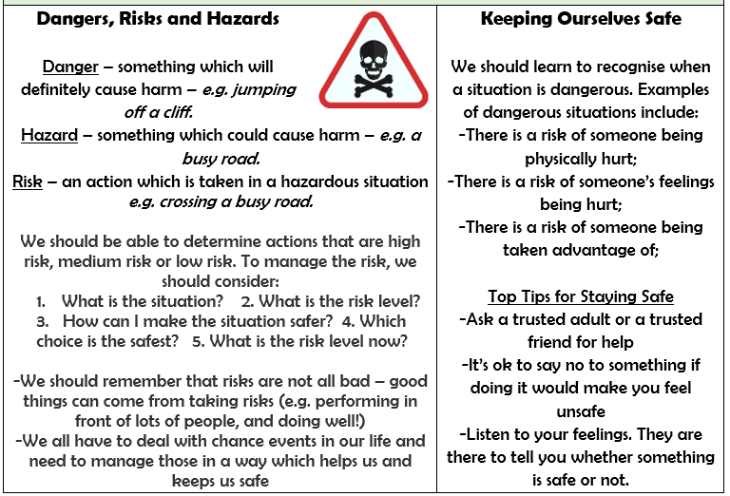
What should I be able to do at the end of the topic?
- How to recognise, predict, assess and manage risk in different situations
- How to keep safe in the local environment and less familiar locations (e.g. near rail, water, road; fire/firework safety; sun safety and the safe use of digital devices when out and about
- How people can be influenced by their peers’ behaviour and by a desire for peer approval; how to manage this influence
- How people’s online actions can impact on other people
- How to keep safe online, including managing request for personal information and recognising what is appropriate to share or not share online
- How to report concerns, including about inappropriate online content and contact
- That rules, restrictions and laws exist to help people keep safe and how to respond if I become aware of a situation that is anti-social or against the law
 | Key Vocabulary

