Knowledge Organiser – Year 4 – PSHE/RSE
– Living in the Wider World – How can our choices make a difference to others and the environment?
– Caring for others; the environment; people and animals; shared responsibilities, making choices and decisions
What do I already know? | 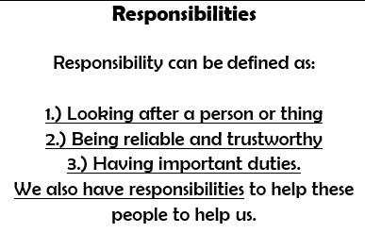  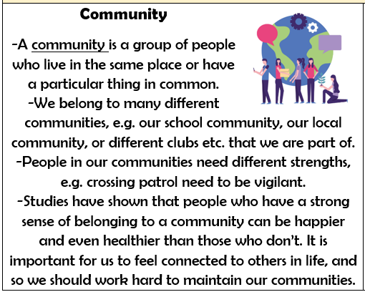  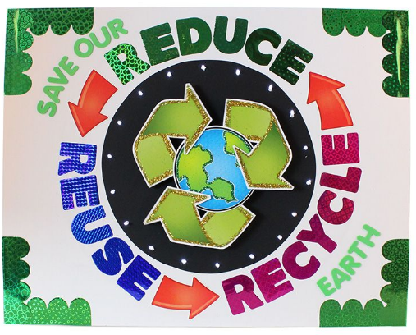
- how kind and unkind behaviour can affect others; how to be polite and courteous; how to play and work co-operatively
- the responsibilities I have in and out the classroom
- how people and animals need to be looked after and cared for
- what can harm the local and global environment; how I and others can help care for it
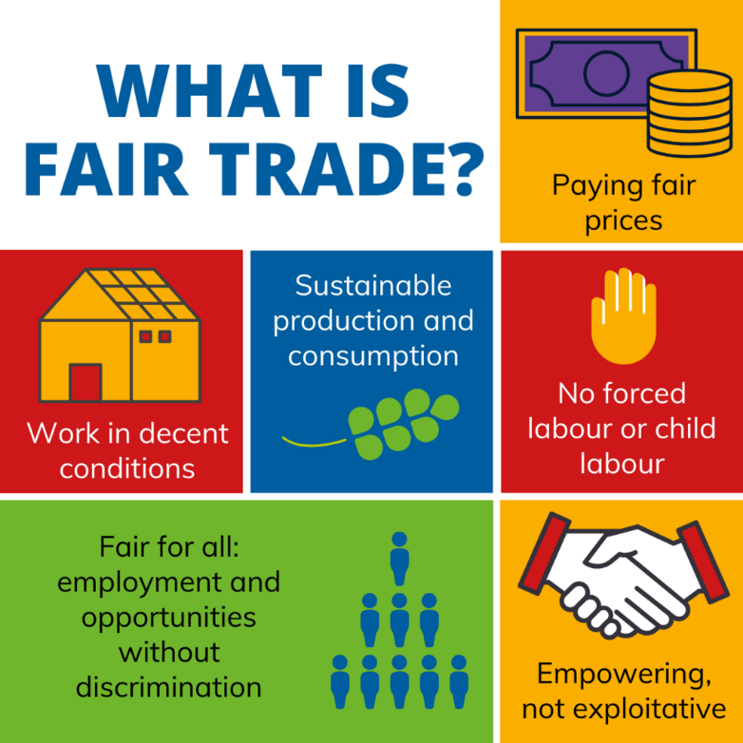

What should I be able to do at the end of the topic?
- How people have a shared responsibility to help protect the world around them
- How everyday choices can affect the environment
- How what people choose to buy or spend money on can affect others or the environment (e.g. Fairtrade, single use plastics, giving to charity)
- The skills and vocabulary to share my thoughts, ideas and opinions in discussion about topical issues
- How to show care and concern for others (people and animals)
- How to carry out personal responsibilities in a caring and compassionate way
 | Key Vocabulary

