Knowledge Organiser – Year 4 – PSHE/RSE
– Health and Wellbeing – How will we grow and change?
– Growing and changing; puberty
What do I already know? | 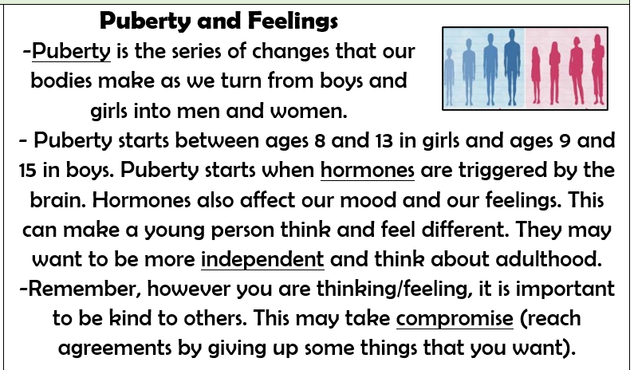  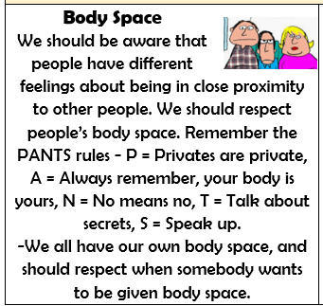    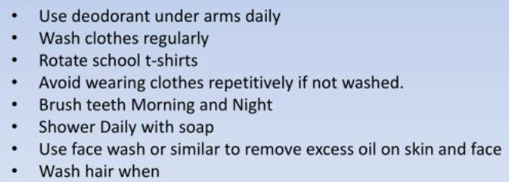
- Our bodies are unique and special.
- Different parts of our bodies have different jobs.
- It is important to respect people’s privacy and only touch appropriately.
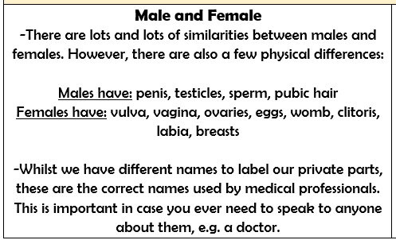

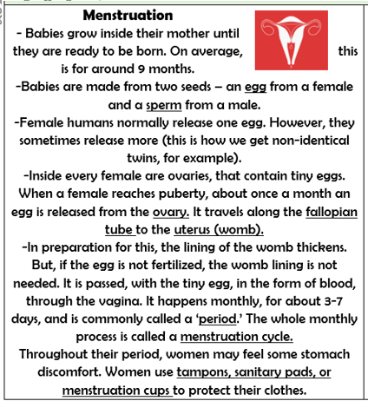

What should I be able to do at the end of the topic?
- About puberty and how bodies change during puberty, including menstruation and menstrual wellbeing, erections and wet dreams
- How puberty can affect emotions and feelings
- How personal hygiene routines change during puberty
- How to ask for advice and support about growing and changing and puberty
 | Key Vocabulary

