Knowledge Organiser – Year 4 – PSHE/RSE
– Health and Wellbeing – How can we manage our feelings?
– Feelings and emotions; expression of feelings; behaviour
What do I already know? | 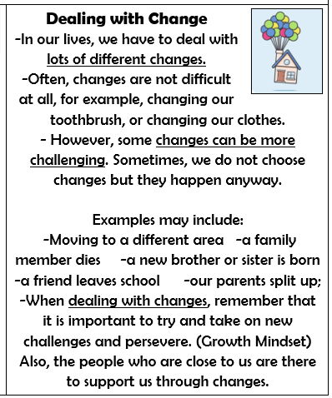  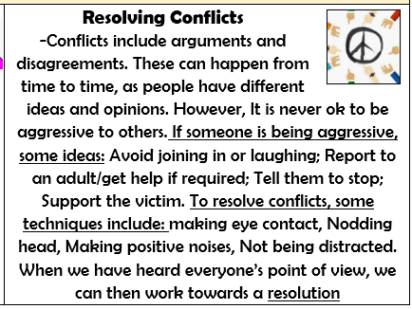  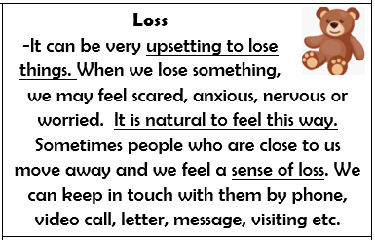
- We are all special and unique. We have similarities and differences. We should celebrate this!
- There are special people in our lives, who can help us feel happy and safe. We have a responsibility to be kind and respectful to the special people in our lives.
- We have many different emotions. We can affect the emotions of ourselves and others through our thoughts, words and actions. Different people may feel differently about the same thing.
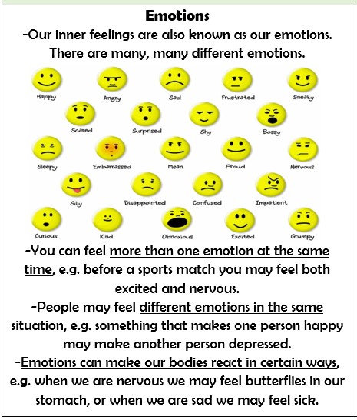

What should I be able to do at the end of the topic?
- How everyday things can affect feelings
- How feelings change over time and can be experienced at different levels of intensity
- The importance of expressing feelings and how I can be expressed in different ways
- How to respond proportionately to, and manage, feelings in different circumstances
- Ways of managing feelings at times of loss, grief and change
- How to access advice and support to help manage my own or others’ feeling
 | Key Vocabulary

