Knowledge Organiser – Year 4 – PSHE/RSE
– Relationships – How do we treat each other with respect?
– Respect for self and others; courteous behaviour; safety; human rights
What do I already know? | 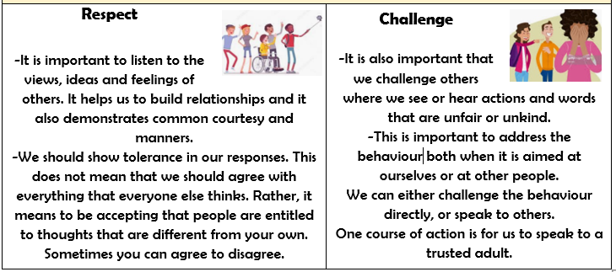  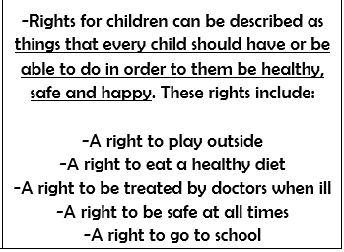  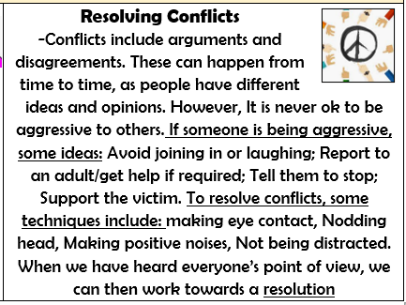
- We have a responsibility to keep ourselves and others safe, and we also have rights to be treated in a certain way.
- There are some people who can help to keep us healthy and safe. We can help them to help us and other people.
- We have a responsibility to follow the rules and laws of our society.
What should I be able to do at the end of the topic?
- How people’s behaviour affects myself and others, including online
- How to model being polite and courteous in different situations and recognise the respectful behaviour I should receive in return
- About the relationship between rights and responsibilities
- About the right to privacy and how to recognise when a confidence or secret should be kept (such as a nice birthday surprise everyone will find out about) or not agreed to and when to tell (e.g. if someone is being upset or hurt)
- The rights that children have and why it is important to protect these
- That everyone should feel included, respected and not discriminated against; how to respond if I witness or experience exclusion, disrespect or discrimination
- How to respond to aggressive or inappropriate behaviour (including online and unwanted physical contact) – how to report concerns
 | Key Vocabulary

