Knowledge Organiser – Year 3 – PSHE/RSE
– Health and Wellbeing – Why should we keep active and sleep well?
– Being healthy: keeping active, taking rest
What do I already know? | 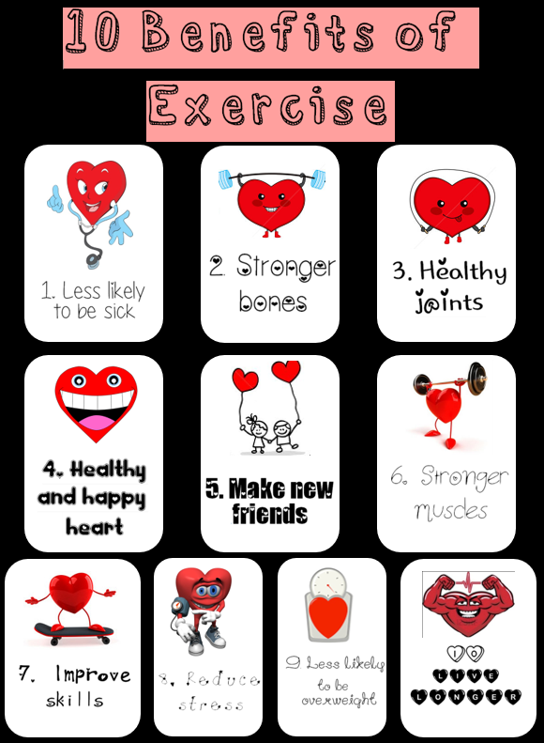  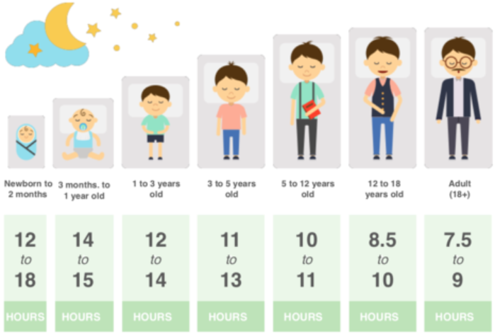
- That different things help my body to be healthy, including food and drink, physical activity, sleep and rest
- How to be physically active and how much rest and sleep I should have everyday
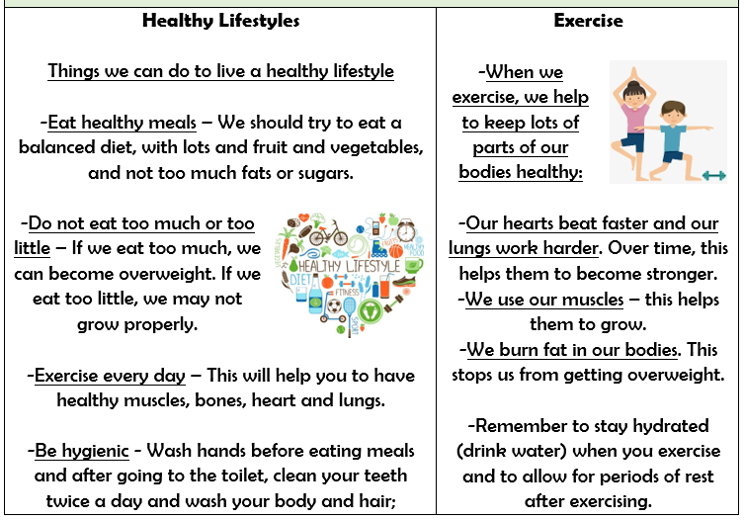

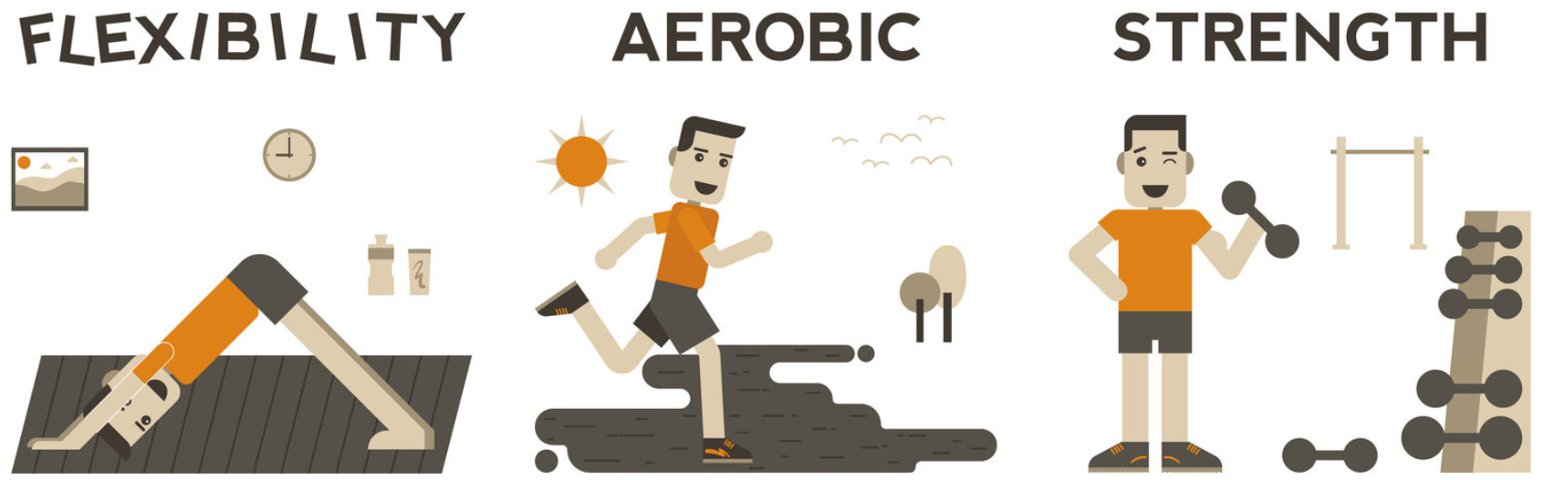

What should I be able to do at the end of the topic?
- How regular physical activity benefits bodies and feelings
- How to be active on a daily and weekly basis – how to balance time online with other activities
- How to make choices about physical activity, including what and who influences decisions
- How the lack of physical activity can affect health and wellbeing
- How lack of sleep can affect the body and mood and simple routines that support good quality sleep
- How to seek support in relation to physical activity, sleep and rest and who to talk to if I am worried
Key Vocabulary

Exercise Strength Healthy

Heart Aerobic Flexible

Rest Muscles Benefit

