Knowledge Organiser – Year 3 – PSHE/RSE
– Health and Wellbeing – Why should we eat well and look after our teeth?
– Being healthy: eating well, dental care
What do I already know? | 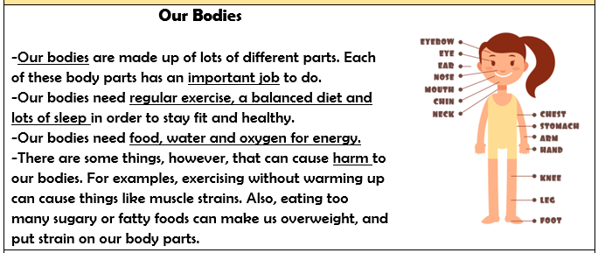  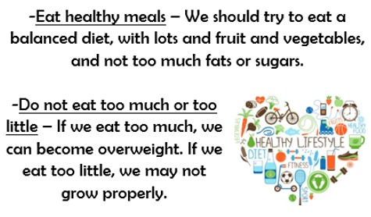  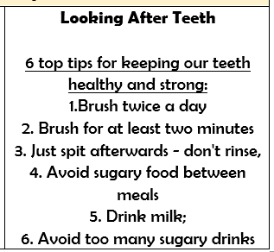
- That different things help my body to be healthy, including food and drink, physical activity, sleep and rest
- That eating and drinking too much sugar can affect my health, including dental health
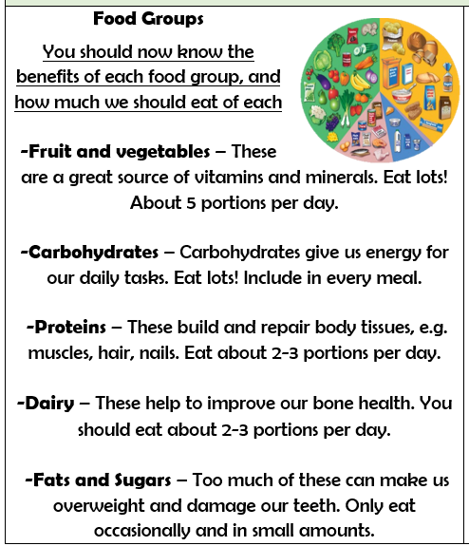

What should I be able to do at the end of the topic?
- How to eat a healthy diet and the benefits of nutritionally rich foods
- How to maintain good oral hygiene (including regular brushing and flossing) and the importance of regular visits to the dentist
- How not eating a balanced diet can affect health, including the impact of too much sugar/acidic drinks on dental health
- How people make choices about what to eat and drink, including who or what influences these
- How, when and where to ask for advice and help about healthy eating and dental care

 | Key Vocabulary

