Knowledge Organiser – Year 3 – PSHE/RSE
– Living in the Wider World – What makes a community?
– Community; belonging to groups; similarities and differences; respect for others
What do I already know? | 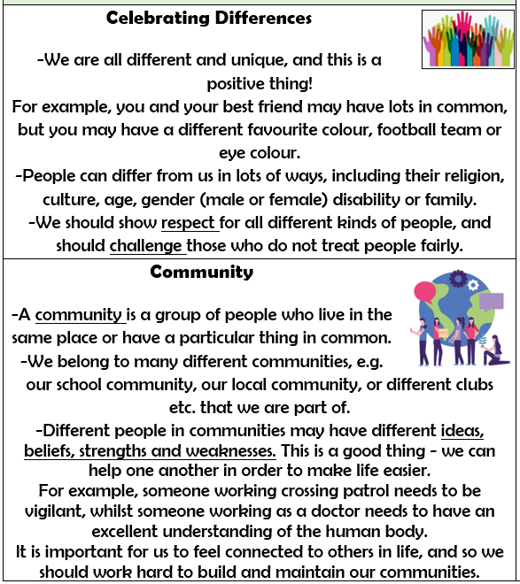  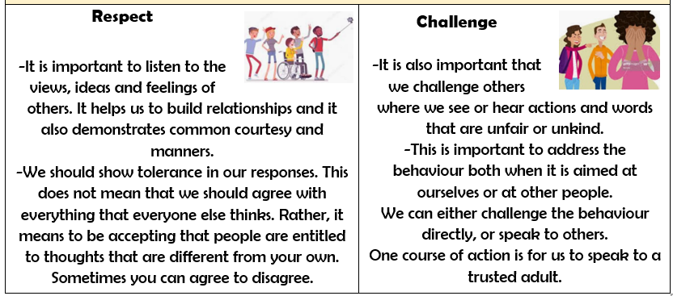
- We have special people in our lives who help and support us. There are ways that other people are similar and different to ourselves, and difference is a good thing!
- It is important to build relationships with family and friends.
- Families come in many different forms. People’s opinions of what a family is may differ.
- We should celebrate that we are all unique and special. We even have differences of opinion and beliefs with our best friends and this should be celebrated.
- Our behaviour affects other people. We should respect other people and challenge unfair and unkind behaviour.
What should I be able to do at the end of the topic?
- How I belong to different groups and communities, e.g. friendship, faith, clubs, classes/year groups
- What is meant by a diverse community; how different groups make up the wider/local community around the school
- How the community helps everyone to feel included and values the different contributions that people make
- How to be respectful towards people who may live differently to me
 | Key Vocabulary

