Knowledge Organiser – Year 3 – PSHE/RSE
– Relationships – What are families like?
– Families; family life; caring for each other
What do I already know? | 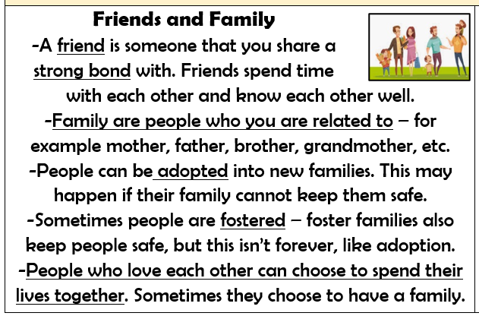  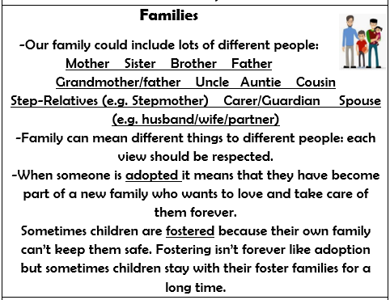  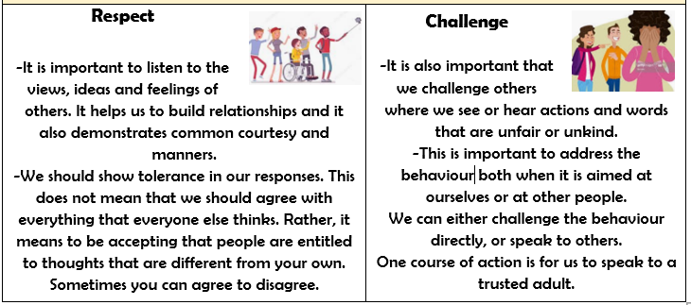
- that family is one of the groups I belong to
- about the different people in my family / those who love and care for me
- what my family members, or people that are special to me, do to make me feel loved and cared for
- how families are all different but share common features – what is the same and different about them
- about different features of family life, including what families do / enjoy together
What should I be able to do at the end of the topic?
- How families differ from each other (including that not every family has the same family structure, e.g. single parents, same sex parents, step-parents, blended families, foster and adoptive parents)
- How common features of positive family life often include shared experiences, e.g. celebrations, special days or holidays
- How people within families should care for each other and the different ways they demonstrate this
- How to ask for help or advice if family relationships are making me feel unhappy, worried or unsafe
 | Key Vocabulary

