Knowledge Organiser – Year 3 – PSHE/RSE
– Health and Wellbeing – What keeps us safe?
– Keeping safe; at home and school; our bodies; hygiene; medicines and household products
What do I already know? | 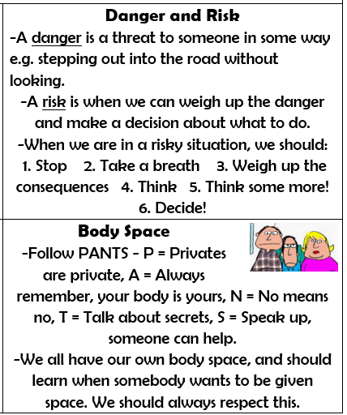  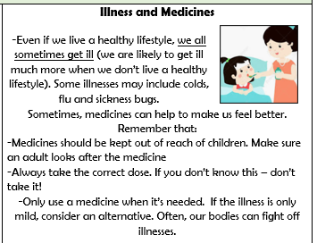  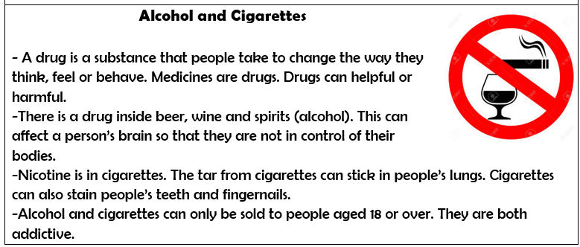
- How to identify risky and potentially unsafe situations (in familiar environments, including online) and take steps to avoid or remove myself from them
- How to resist pressure to do something that makes me feel unsafe or uncomfortable, including keeping secrets
- How not everything I see online is true or trustworthy and that people can pretend to be someone they are not
- How to tell a trusted adult if I am worried for myself or others, worried that something is unsafe or if I come across something that scares or concerns me
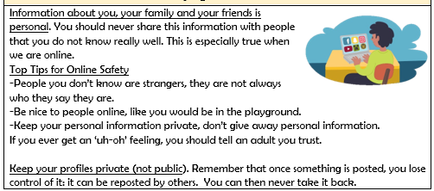
What should I be able to do at the end of the topic?
- How to recognise hazards that may cause harm or injury and what I should do to reduce risk and keep myself (or others) safe
- How to help keep my body protected and safe, e.g. wearing a seatbelt, protective clothing and stabilizers
- That my body belongs to me and should not be hurt or touched without my permission; what to do and who to tell if I feel uncomfortable
- How to recognise and respond to pressure to do something that makes me feel unsafe or uncomfortable (including online)
- How everyday health and hygiene rules and routines help people stay safe and healthy (including how to manage the use of medicines, such as for allergies and asthma, and other household products, responsibly)
- How to react and respond if there is an accident and how to deal with minor injuries e.g. scratches, grazes, burns
- What to do in an emergency, including calling for help and speaking to the emergency services
 | Key Vocabulary

