Knowledge Organiser – Year 3 – PSHE/RSE
– Relationships –How can we be a good friend?
–Friendship; making positive friendships, managing loneliness, dealing with arguments
What do I already know? | 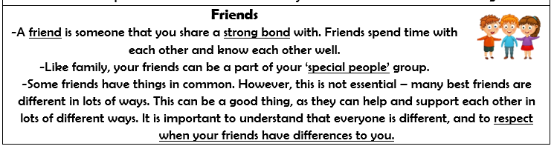  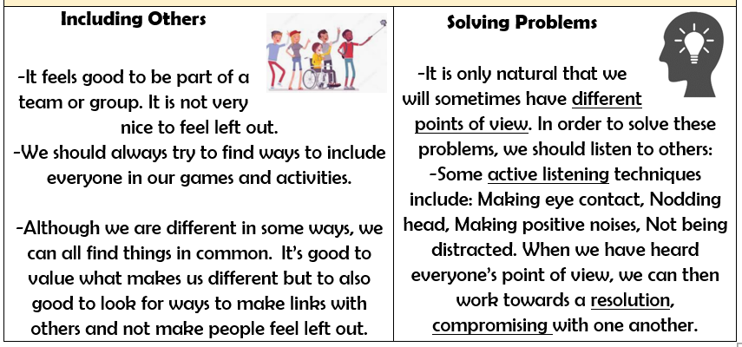
- How to make friends with others
- How to recognise when I feel lonely and what I could do about it
- How people behave when they are being friendly and what makes a good friend
- How to resolve arguments that can occur in friendships
- How to ask for help if a friendship is making me unhappy
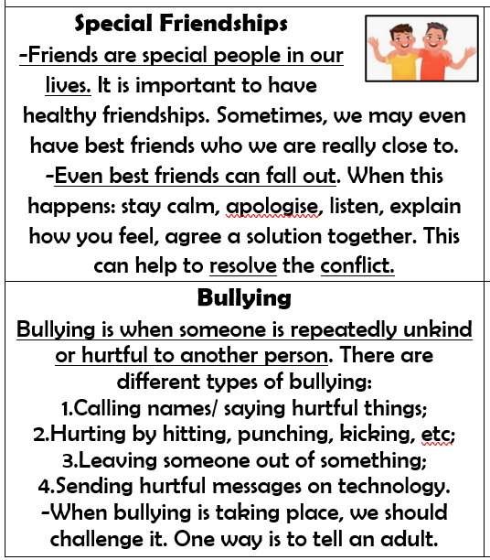

What should I be able to do at the end of the topic?
- How friendships support wellbeing and the importance of seeking support if feeling lonely or excluded
- How to recognise if others are feeling lonely and excluded and strategies to include them
- How to build good friendships, including identifying qualities that contribute to positive friendships
- That friendships sometimes have difficulties, and how to manage when there is a problem or an argument between friends, resolve disputes and reconcile differences
- How to recognise if a friendship is making me unhappy, feel uncomfortable or unsafe and how to ask for support
 | Key Vocabulary

