Knowledge Organiser – Year 2 – PSHE/RSE
– Health and Wellbeing – How do we recognise our feelings?
– Feelings; mood; times of change; loss and bereavement; growing up
What do I already know? | 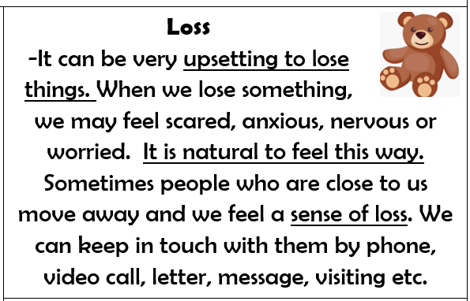  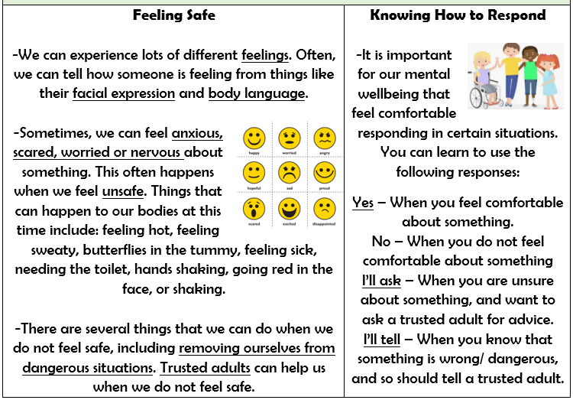  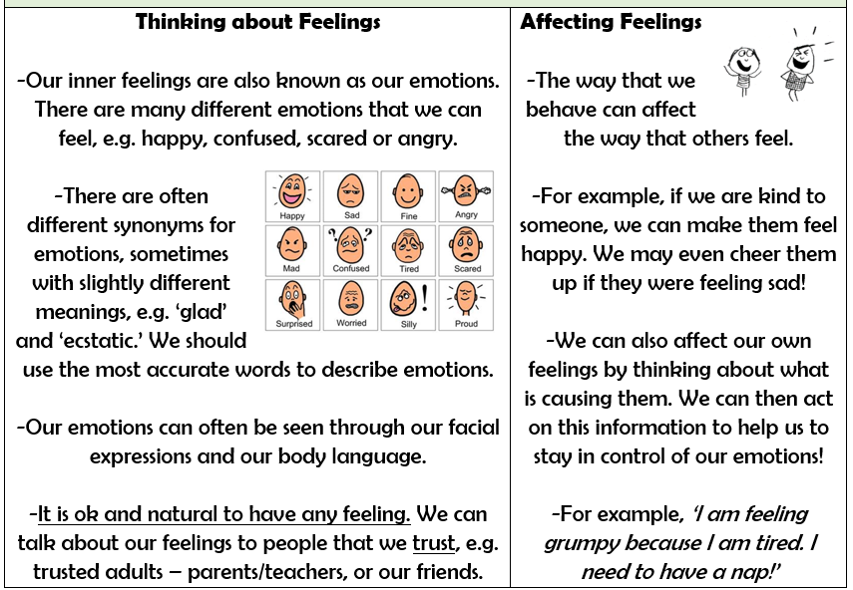
- We are all special. We have some things that make us similar to other people, and some things that make us different to other people.
- It is nice for us to spend time with other people. Sometimes, we also like to be alone.
- We have many different feelings, e.g. happy, sad, excited, disappointed and angry.
- There are ways that we can help ourselves feel better. Sometimes, other people can also help us to feel better too. Different people can help us at different times.
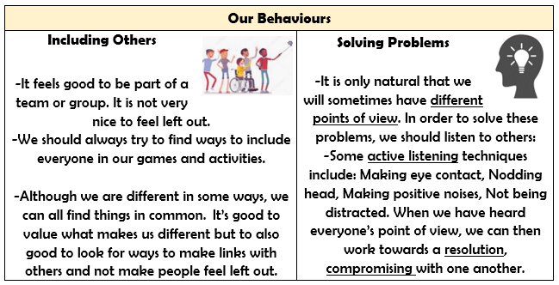

What should I be able to do at the end of the topic?
- How to recognise, name and describe a range of feelings
- What helps me to feel good, or better if not feeling good
- How different things/times/experiences can bring about different feelings for different people (including loss, change and bereavement or moving on to a new class/year group)
- How feelings can affect people in their bodies and their behaviour
- Ways to manage big feelings and the importance of sharing my feelings with someone I trust
- How to recognise when I might need help with feelings and how to ask for help when I need it
Key Vocabulary

