Knowledge Organiser – Year 2 – PSHE/RSE
– Health and Wellbeing – What helps us stay safe?
– Keeping safe; recognising risk; rules
What do I already know? | 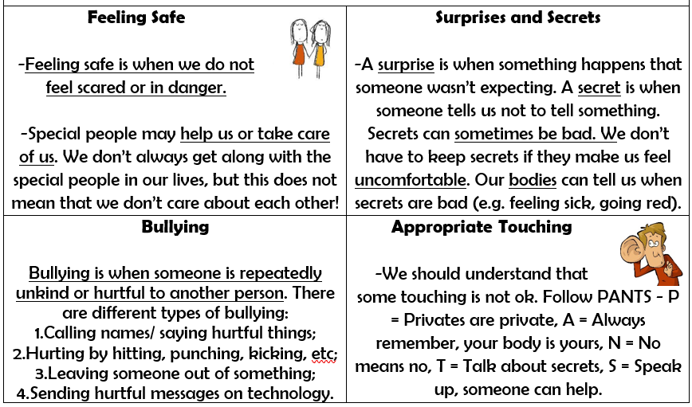
- Being healthy is about feeling good in your body and wellbeing is about feeling good in your mind.
- When we have a bad feeling about something or feel unsafe, trusted adults can help us.
- It is important for our wellbeing that we know how to respond in different situations.
- There are some things that we are responsible for, e.g. looking after ourselves, other people and our things.
- There are places where we should feel safe. When a situation is not safe, we should get help from a trusted adult.
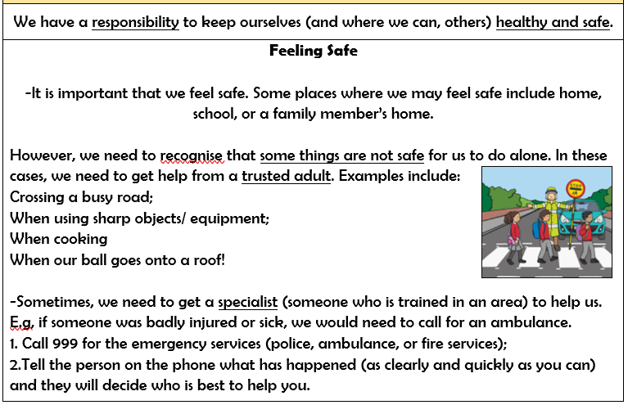

What should I be able to do at the end of the topic?
- How rules and restrictions help me to keep safe (e.g. basic road, fire, cycle, water safety; in relation to medicines/household products and online)
- How to identify risky and potentially unsafe situations (in familiar environments, including online) and take steps to avoid or remove myself from them
- How to resist pressure to do something that makes me feel unsafe or uncomfortable, including keeping secrets
- How not everything I see online is true or trustworthy and that people can pretend to be someone they are not
- How to tell a trusted adult if I am worried for myself or others, worried that something is unsafe or if I come across something that scares or concerns me

 | Key Vocabulary

