Knowledge Organiser – Year 2 – PSHE/RSE
– Living in the Wider World – What jobs do people do?
– People and jobs; money; role of the internet
What do I already know? | 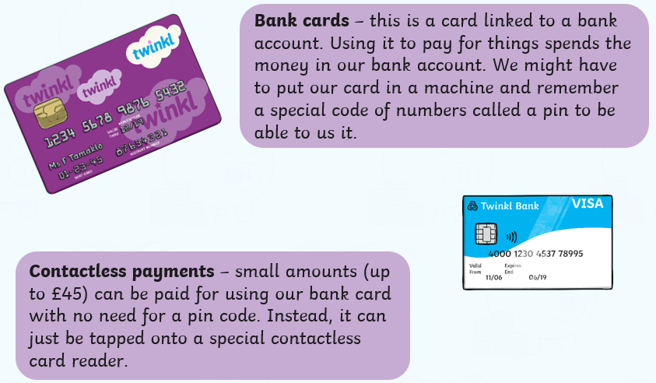  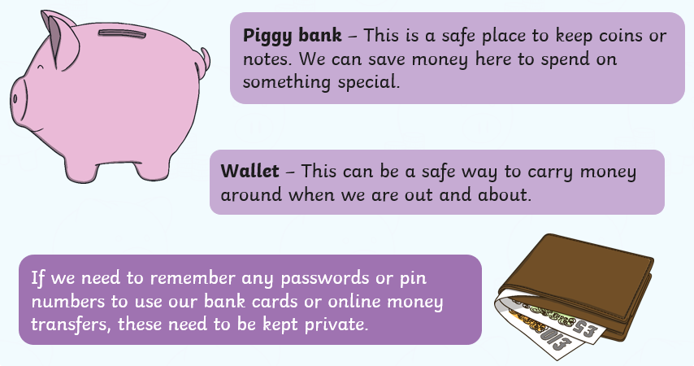  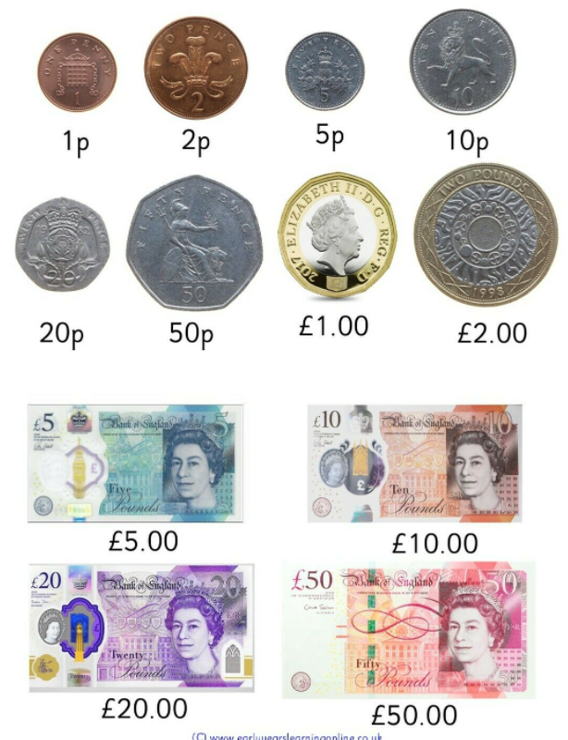
- what money is – that money comes in different forms
- how money is obtained
- how people make choices about what to do with money, including spending and saving
- the difference between needs and wants – that people may not always be able to have the things they want
- how to keep money safe and the different ways of doing this
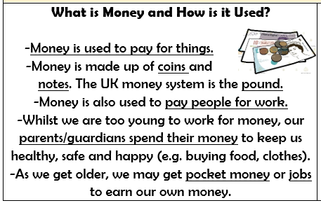

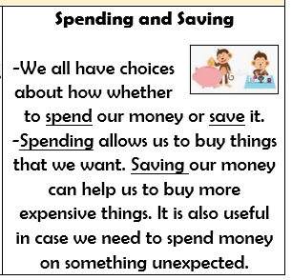

What should I be able to do at the end of the topic?
- How jobs help people earn money to pay for things they need and want
- About a range of different jobs, including those done by people they know or people who work in their community
- How people have different jobs, including those done by people they know or people who work in their community
- How people have different strengths and interests that enable them to do different jobs
- How people use the internet and digital devices in their jobs and everyday life
 | Key Vocabulary

