Knowledge Organiser – Year 2 – PSHE/RSE
– Relationships – What is bullying?
– Behaviour; bullying; words and actions; respect for others
What do I already know? | 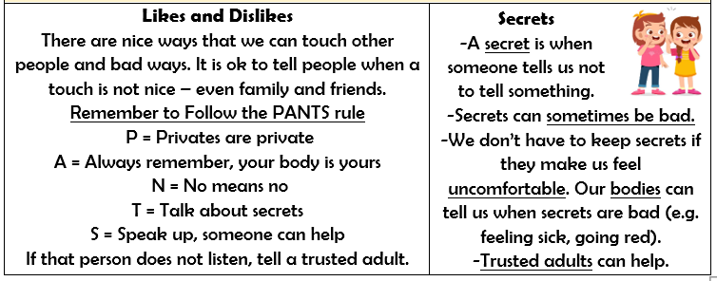  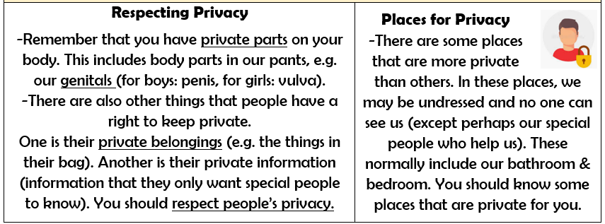  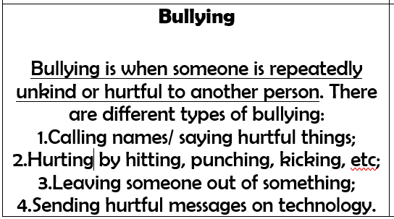
- We are all unique, and this is a good thing! This includes our bodies. Some parts of our bodies are private and other people do not have a right to see/ touch them.
- We also have a right to keep private belongings and information private from others.
- When we have a bad feeling about something or feel unsafe, trusted adults can help us.
What should I be able to do at the end of the topic?
- How words and actions can affect how people feel
- How to ask for and give/not give permission regarding physical contact and how to respond if physical contact makes me uncomfortable or unsafe
- Why name-calling, hurtful teasing, bullying and deliberately excluding others is unacceptable
- How to respond if this happens in different situations
- How to report bullying or other hurtful behaviour, including online, to a trusted adult and the importance of doing so
 | Key Vocabulary

